Scientists deliberate on possibilities, challenges & scope of AI technologies at the launch of USIAI

Eminent scientists working in the field of Artificial Intelligence (AI) from across the world deliberated on the possibilities, challenges, and scope of AI technologies bringing about breakthrough solutions in a range of sectors, like agriculture, energy, climate change, affordable housing, and smart cities at a panel discussion recently on the occasion of the launch of the U.S. India Artificial Intelligence (USIAI).

The scientists highlighted how the newly launched U.S. India Artificial Intelligence (USIAI) could bring together experts from around the world for more such discussions.
“USIAI will serve as a platform to discuss opportunities, challenges, and barriers for bilateral AI R&D collaboration, enabling AI innovation, share ideas for developing an AI workforce and recommend modes and mechanisms for catalyzing partnerships. This is a great chance for two countries to synergize research and explore various possibilities,” said Professor Sandeep Verma, Secretary, Science, and Engineering Research Board (SERB), at the online panel discussion.

Padmanabhan Anandan, CEO, Wadhwani Institute for Artificial Intelligence, said that AI can help solve problems in many sectors. “It may not solve all the problems but can certainly help us find problem areas and control problems,” he said.

“The possibility through this collaboration in various sectors like healthcare, agriculture, climate control, smart cities, etc., and improving social-economic level by bringing together stakeholder and solve problems is enormous,” said Aseem Ansari, Chair Chemical Biology and Therapeutics, St Jude Children's Research Hospital, Memphis.

Jim Kurose, Distinguished University Professor, College of Information and Computer Sciences, University of Massachusetts Amherst hoped that long-term collaboration between the two countries would be able to tackle the challenges of the future.

“Availability of data and technique excitement has caused a revolution in the AI domain. The field requires thinking on interdisciplinary things and needs to have partners for programs. The shortage of people with the right skills is acute in India, and it is a problem in the US too. Such challenges can be overcome through collaboration, and good science can be done,” said Jitendra Malik Electrical Engineering and Computer Sciences University of Californie Berkeley.

R. Ramanan, Director of the Atal Innovation Mission (AIM), NITI Aayog Government of India, said that demographic dividend is one of the biggest advantages for India. “Around 150 million students are going to enter the workforce in 5-10 years. Our goal is to drive and create a culture of innovation among this workforce, and this collaborative can help drive the culture of innovation to find a solution for problems of both the countries,” he added.

Speaking on the need for AI in improving biomedicine supply and infrastructure by use of AI, Anurag Agarwal, Director, Institute of Genomics and Integrative Biology, remarked, “In biomedicine, there is a huge scope of growth by the use of AI. The first is that while we are very good at generating data, we do not necessarily know what to do with it. The second type of problem in biomedicine is that you know what to do, but only a few humans have been training to do it. The third problem is that we have the people, we have the process but do not have scale and sufficiency.”

Elizabeth Urbanas, Deputy Assistant Secretary for Asia and the Americas, U.S. Department of Energy, said that AI can strengthen bilateral energy partnerships between the United States and India. “We have several areas that we envision working with the IUSSTF program on. We are also looking forward to leveraging this platform and its engagement to help bolster our existing bilateral energy partnerships in India, where we share priorities to modernize and strengthen the grid, enhance grid integration of renewables for reliable energy supply, promote smart and innovative efficient buildings and material and decarbonize and electrify the industrial sector,” she said.

The Indo-U.S. Science and Technology Forum (IUSSTF) was established in 2000 under an agreement between the Governments of India and the United States. It operates through two bilateral agreements: Indo-U.S. Science and Technology Forum (2000) and United States-India Science and Technology Endowment Fund (2009).

The scientists also discussed future security and privacy concerns surrounding AI and also how AI tools and technologies could transform several sectors of the economy - from deep learning algorithms for cancer diagnosis, application of machine learning to discover new materials, the use of 3D printers in advanced manufacturing, to intelligent systems with cognition and decision-making abilities.
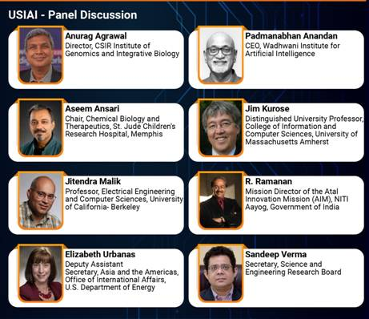

Source
Press Information Bureau, 21 March, 2021

