Over 3000 COVID-19 samples tested at CSIR-NEERI

The COVID-19 testing facility has become operational at CSIR-National Environmental Engineering Research Institute (CSIR-NEERI) from April 2020. So far more than 3,000 samples have been tested for COVID-19.

With testing capacity of 50 samples per day, CSIR-NEERI has the requisite infrastructure to test COVID-19 samples and take all appropriate bio-safety and bio-security precautions before testing. All the mandatory approvals required for testing of clinical samples were obtained to operationalise the testing facility, say Dr. Rakesh Kumar, director, CSIR-NEERI.
“The facility is open to testing COVID-19 samples from Nagpur and surrounding areas of Vidarbha. Apart from testing of clinical samples, the CSIR-NEERI is also supporting healthcare professionals by providing Personal Protective Equipment (PPEs) to prevent them from contracting any infection while serving patients”, said Dr. Prakash Kumbhare, scientist at the CSIR-NEERI.

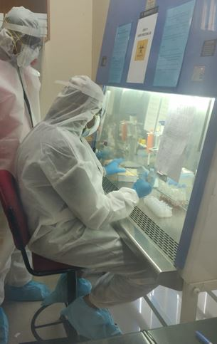
CSIR-NEERI Virology Lab that tests for the virus

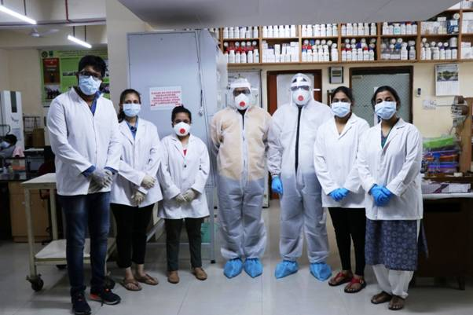
CSIR-NEERI Virology Lab team engaged in COVID-19 testing

Source
Press Information Bureau, 24 June, 2020

