SCTIMST & IIT Madras start-up set up portable hospital infrastructure for COVID -19

“Foldable, portable, pre-fab hospitals that are easy to assemble on-site quickly provide a compelling solution to effectively addressing the needs of pandemics, disasters, and other contingencies”-- Prof Ashutosh Sharma
It comes equipped with a prefabrication modular technology and a telescopic frame that allows the model to be shrunk to 1/5th of its original size, which makes it convenient for storage and transportation
As of now, a 30 bedded hospital at a cost of 34 lakhs (INR) at Chengalpet, Chennai at SugaHhealthcorp Private Corporation, and another 12 bedded hospital in Waynad, Kerala at a cost of Rs 16 Lakh at Primary Health Care, Varadoor- Govt. Organisation have been successfully installed as four-zone hospitals

The COVID 19 pandemic has highlighted the need to set up systems to improve health infrastructure, particularly in rural areas. Portable hospitals for detecting, screening, identifying, isolating, and treating COVID-19 patients in local communities could soon be a solution to tackle the increasing demands for health infrastructure.

Sree Chitra Tirunal Institute for Medical Sciences and Technology (SCTIMST), an autonomous institute under the Department of Science and Technology (DST), Govt. of India in collaboration with ‘Modulus Housing’ a start-up incubated by IIT Madras has come up with a solution using decentralised approach to detect, manage and treat COVID-19 patients in local communities through portable microstructures.

Mr. Subhash NN and Mr. Muraleedharan CV, scientists from SCTIMST along with Mr. Shreeram Ravichandran, Chief Executive Officer, Modulus Housing including his associates have developed the portable microstructure named as “MediCAB”, which is modular, portable, durable, easy to set up and can be customised as per the requirements of the customer. It is foldable and is composed of four zones – a doctor's room, an isolation room, a medical room/ward, and a twin-bed ICU, maintained at negative pressure. It can be easily transported and installed anywhere in geographic locations and can be erected in just two hours with the help of four persons. The cabins in the MediCAB are tightly sealed and are dust-proof. It has in-built electricals, which are just plug-n-play. MediCAB can withstand harsh weather and heavy rains as well.

It comes equipped with a prefabrication modular technology and a telescopic frame that allows the model to be shrunk to 1/5th of its original size, which makes it convenient for storage and transportation. These portable units come in three sizes – 200, 400, and 800 sqft. The units can be installed at the car parking or at the terrace of the hospital according to the needs or availability of space at the facility.

As of now, a 30 bedded hospital at a cost of 34 lakhs (INR) at Chengalpet, Chennai at SugaHhealthcorp Private Corporation, and another 12 bedded hospital in Waynad, Kerala at a cost of Rs 16 Lakh at Primary Health Care, Varadoor- Govt. Organisation have been successfully installed as four-zone hospitals.

The team of Modulus Housing says that it is working on a dual design where these mobile hospitals can be rapidly launched as COVID-19 isolation wards. Modulus housing has delivered emergency housing solutions to prestigious clients across sectors such as L&T, Tata Group, and Shapoorji, Selco, during flooding. The Union Human Resources Ministry has lauded the effort on their social media platform.

“Foldable, portable, pre-fab hospitals that are easy to assemble on-site quickly provide a compelling solution to effectively addressing the needs of pandemics, disasters, and other contingencies,” said Prof Ashutosh Sharma, Secretary, DST.

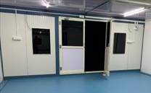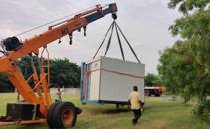

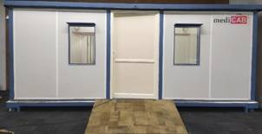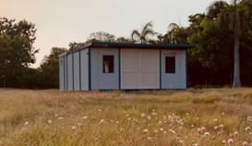
[For further details, Mr. Subhash NN (Subhashnn@sctimst.ac.in) and Mr. Shreeram Ravichandran (Shreeramdpm@gmail.com) can be contacted.

Author:
Originally from India, Er. Arvind Kumar Prajapati is a Scientist/Engineer at Sree Chitra Tirunal Institute for Medical Sciences & Technology who now lives in Trivandrum, Kerala. Arvind has about eight years of work experience in Medical Devices, New Product Development Process (NPDP), CAD modeling (PTC Creo), Design Control documents (DIOVV, DFMECA), Verification activity & Tolerance analysis, Finite Element Analysis, Welding, Biomechanics of Knee & Hip joint, Geometric Dimensioning and Tolerancing (GD&T), Manufacturing Methods, Design & development of customised Knee & Hip instruments.
Web page: https://sctimst.ac.in/People/arvind]

Source
Press Information Bureau, 19 August, 2020

