IIT Guwahati develops affordable diagnostic kits for COVID-19

Accurate testing is important to get out of the clutches of novel coronavirus. Stepping up efforts in this regard, the Indian Institute of Technology (IIT) Guwahati, in association with RR Animal Healthcare Ltd and Guwahati Medical College and Hospital (GMCH), has developed low-cost diagnostic kits. These are Viral Transport Media (VTM) kits, RT-PCR kits, and RNA isolation kits.

The VTM kits are the first-stop source used to collect nasal and oral swab specimens from an individual source to a laboratory safely for culture and testing. During this period, the virus, if present, in the sample specimens should remain intact until the testing procedure is completed. The kit consists of a comprehensive solution specially formulated for the collection and transport of SARS-CoV-2.

“To bring down the cost of kits, we have used material that are available in the local market and they are as per the World Health Organisation (WHO) recommendation. We have handed over two batches of these kits to the National Health Mission, Assam, and GMCH. We are making them in bulk to make it available to larger population,” said Prof. Parameswar Krishnan Iyer, lead researcher, IIT Guwahati.

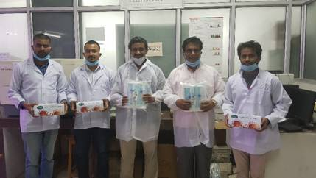

(From L to R) Laxmi Raman Adil, PhD student (IIT Guwahati), Dr. Pankaj Choudhury (RR Animal Health Care), Prof. ParameswarIyer and Prof. Siddhartha Ghosh (IIT Guwahati), Dr. Anil Bidkar (RR Animal Health care)

These kits comprise two transport media, one for nasopharyngeal and the other for oropharyngeal specimen collection swabs. Both of these are safe to use as they are recommended and validated by the Centre for Disease Control and Prevention (CDC) as well. . The complete package is suitable for the collection, transport, maintenance, and long-term freezer storage of viral specimens. The unique formulation of the transport medium helps in preserving the viability of viruses for up to 72 hours (at refrigerated temperatures).

The swabs have been designed ergonomically with a pre-molded breakpoint on their shaft for enabling secure sampling. These sterile VTM kits comply with the CDC-recommended configurations for viral specimen collection for COVID-19 and are packed in user-friendly individual packs. “These kits will spur development of affordable and high-quality healthcare products in Assam and provide access to world-class kits and career opportunities to healthcare professionals and students,” said Prof Iyer.

In addition to the sterile VTM kits, the Institute has also developed RNA isolation kits and RT-PCR kits jointly with RR Animal Healthcare Ltd. The isolated and purified RNA is then converted to DNA by an enzyme Reverse Transcriptase (RT), which is used to confirm the presence or absence of COVID-19. The large-scale production of all these kits has commenced to meet the requirement of Assam and will be made available across the country soon.

Source
Press Information Bureau, 19 June, 2020

