Indian industries respond enthusiastically to TDB’s invitation for proposals for fighting COVID 19
The Indian industry and the start-up ecosystemhave responded enthusiastically to the invitation by the Technology Development Board (TDB), a statutory body of the Department of Science and Technology (DST), for proposals from Indian companies and enterprises for supporting technologically innovative solutions towards fighting COVID-19.

TDB provides financial support to Indian companies for commercialization of indigenous technology or adaptation of imported technology and had invited proposals on March 20, 2020, to strengthen the nation’s core capacities in fighting COVID 19. It covered key areas like surveillance, laboratory support, infection prevention and control, logistics, risk communication, and, in particular, to strengthen the capabilities in terms of isolation and management of critically ill patients for containing and preventing the spread of the pandemic.

The impact of the call was widespread, and within the first week, more than 300 companies marked their presence by registering on TDB Portal. In addition, 140 companies have submitted their proposals till date. Many of these are from Startups offering innovative solutions covering the gamut of areas.

Professor Ashutosh Sharma, Secretary, DST, said, "TDB call to support the manufacturing of full spectrum of products and technologies relevant to COVID-19 has rapidly brought to the surface latent capabilities of our startups and MSMEs. The nation needs to offset our losses quickly and fully and move ahead with renewed vigor to meet the challenges of manufacturing indigenous technology. Every step taken in this direction will have a multiplier effect."

Several proposals have been received on diagnostic kits includeReal-Time Reverse Transcriptase PCR (RT- PCR) as well as antibody rapid tests. The solutions offered range from paper-based to on-chip assays and even Nano-fluidic platforms for point of care applications.

In the Biotech domain, some are for vaccine development, some for the point-of-care device for identifying the severity of disease based on markers, and the rest are for products obtained from natural sources as a means to improve health conditions.

Various companies have offered solutions for production of cost-effective masks at large scale introducing innovations in design, material, and production techniques. The majority of the solutions in this area are cost-effective normal masks, including knitted face mask. In addition, antiviral drug 3D printed mask, nanofiber coated N-95 mask, Povidone Iodine thin-film coated mask is being proposed for mass consumption.

For large area sanitization and sterilization proposals received include variety of solutions from hand sanitizers to automated disinfection robots using Full Depth Disinfection Cycle (FDDC) technology for large area sanitization. Many companies have explored antiviral properties of the silver nanoparticles for disinfection in their products, usage of germicidal properties of the UV rays in disinfection chambers, thymol, and liquid ozone-based disinfection technologies as well as innovative spraying guns like electrostatic sprayer.

Some of the solutions proposed under the thermal scannerenable and ensure the availability of the quality thermal imaging, screening system with high-resolution temperature range, less than 0.3 degrees, along with mass-scale initial screening provision. Some of these companies have claimed to employ computing techniques & artificial intelligence to achieve better scanning results as well as innovative solutions using Information Technology for quarantine monitoring of food and drug delivery, apps for self-assessment, and telemedicine. The projects are being evaluated by expert committees for their technical competence and financial support.

(For more details, Cdr Navneet Kaushik, Sc 'E', Technology Development Board, navneetkaushik.tdb@gmail.com, Mob: 9560611391)

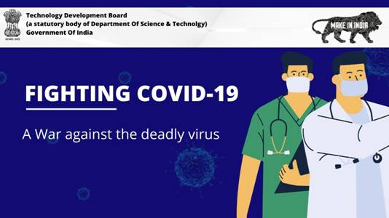

Source
Press Information Bureau, 11 April 2020

