DST Secretary launches Logo & announces series of activities to celebrate Golden Jubilee Commemoration Year

Secretary Department of Science and Technology (DST) Prof Ashutosh Sharma launched the official Logo to celebrate Golden Jubilee Commemoration Year and also announced that since this is the golden jubilee year of DST, many activities like special lecture series of 15-20 lectures in the form of webinars and short feature films on each Autonomous Institutions are planned throughout the year.

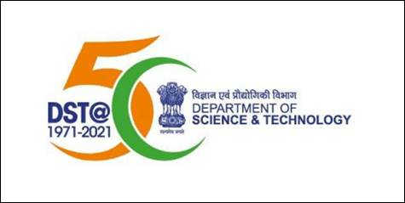

He urged each AI to actively participate and provide inputs to create awareness about their institute, current facilities, and areas of research through these activities.

Prof. Ashutosh Sharma mentioned that the newly launched logo will be printed on stationery items of DST, social, digital, and print documents. He urged all the Directors of the AI’s to use the newly launched 50 Year logo by representing it on banners in conferences held in the institutes. The institutions should co-brand the lecture series with the DST logo to create greater awareness about 50 years of existence of DST.

“DST is planning to make 3 Coffee table books both in physical and digital form one of which will be dedicated to the AI’s based on their journey, milestones, impacts, and outcomes in these 50 years,” Prof. Sharma said. He invited ideas and inputs from AI’s for the coffee table book to take a look at the significance of our journey and to look forward to another 50 years.

“Institutes which have facilities like museums can make a digital walkthrough or virtual tour which gives realistic version of what they are doing. This can turn into a rich source material and in this way institutes can reach out to the whole world which is otherwise limited due to the virus situation at present,” he added.

Department of Science & Technology, which was established on 3rd May 1971, is observing Golden Jubilee Commemoration Year during the period 3rd May 2020 to 2nd May 2021 with activities like lecture series, bringing out publications, documentaries, updating Wikipedia pages of Survey of India, and Autonomous Institutions under DST and events by DST autonomous organisations across the country.

Source
Press Information Bureau, 26 June, 2020

