Study shows significant reduction of heavy metal pollution during COVID-19 pandemicin the Ganga water
Efforts to minimize industrial wastewater can substantially reduce heavy metal pollution in the Ganga water in a short time span of a few months, a study carried out during the COVID-19 pandemic has shown.

The COVID-19 pandemic lockdown provided a team of scientists from Indian Institute of Technology Kanpur a rare opportunity to quantify the impact of restricted anthropogenic activities on the water chemistry resilience of large rivers.

They analyzed the daily geochemical record of the Ganga River and showed that reduced industrial discharge during 51 days of mandated nationwide lockdown decreased the dissolved heavy metal concentrations by a minimum of 50%. In contrast, inputs from agricultural runoff and domestic sewage like nitrate and phosphate remained almost the same as these sources were not impacted by the nationwide confinement.

The research is supported by the Indo-U.S. Science and Technology Forum (IUSSTF), a bilateral organization under the Department of Science and Technology (DST), Government of India and U.S. Department of States, and recently published by ‘Environmental Science and Technology Letters’, showed the high resilience of dissolved heavy metals.

The study, which adds to the body of research world’s large rivers have been intensely studied to better understand the impact of climate change and direct human interventions on river water quality and quantity has found pace in the cover page of the journal.

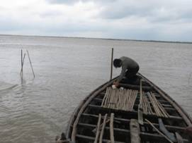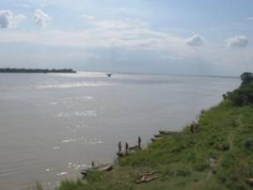
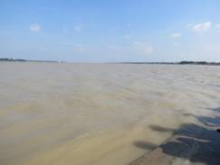
Figure: Photographs shot at downstream locations in the plains during the research work
[Publication link: https://pubs.acs.org/doi/full/10.1021/acs.estlett.0c00982

For more details, Indra S. Sen (isen@iitk.ac.in) can be contacted.]

Source
Press Information Bureau, 08 February, 2021

