DST supports assistive tools, technologies and techniques to combat challenges faced by Divyangjan& Elderly during COVID-19
Devices have been tailor-made for the current COVID-19 situations

The Department of Science and Technology has taken several initiatives to mitigate the impact of COVID-19 among Divyangjan and Elderly and identified various challenges faced by them for finding technological solutions.

The organizations supported by Science for Equity Empowerment and Development(SEED) Division of DST have been instrumental in developing various assistive tools, technologies and techniques, that are affordable and adaptable to the Indian milieu through its programme on Technology Interventions for Disabled and Elderly (TIDE), for creating inclusiveness and universal accessibility for Divyangjan and Elderly.

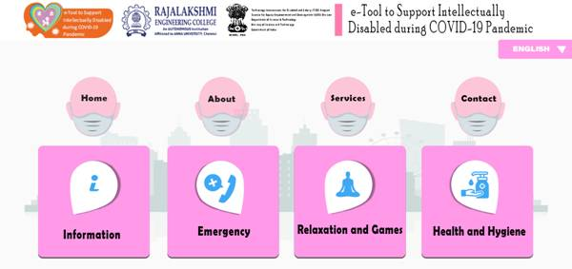
Under this programme an e-Tool to create awareness and impart health and hygiene related information along with education and entertainment to overcome loneliness of the persons with intellectual disabilities, due to COVID-19 pandemic has been developed by Rajalakshmi Engineering College, Chennai. This will help the persons with Intellectual Disability to learn with fun through Tabs and mobiles. The e-Tool can also be converted to other vernacular languages and the Beta Version of the e-tool is being used by 200 specially-abled children.

Prof Ashutosh Sharma, Secretary, DST while stressing the importance of this less known S&T field for providing greater autonomy to Divyangjan and Elderly, called for development of more and more technically feasible and economically viable S&T solutions for Elderly and Divyangjan, which are the need of the hour for creating an inclusive society.

Screenshot of the e-Tool showing different components of the software/app
A wearable sensor device has been developed by PSG College of Technology, Coimbatore to remotely monitor the activities of Elderly and Divyangjan staying alone or those who happen to be under quarantine or isolation wards. The device also predicts and detects fall and frailty levels in Elderly. The device costs Rs.1500/- when produced in bulk.
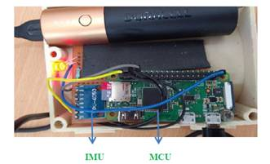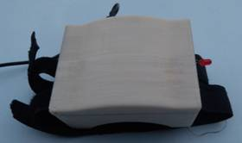

Wearable device Sensor Configuration

A wearable rehabilitation band with real time monitoring and feedback of recovery process through guided rehabilitation protocols has been developed for elderly with motor function disabilities. The device will help the elderly to get quantified outcomes regarding the improvement in the muscle strength, muscle flexibility and muscle endurance during the course of rehabilitation, without direct and physical interventions from doctors and physiotherapists.
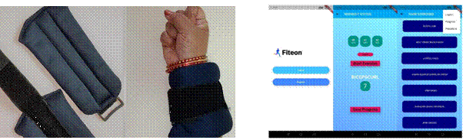
Wearable device User interface of the mobile app

These devices have been tailor-made for the current COVID-19 situations and further process is on for developing apps for recognition of objects, distances, scene recognition, people identification which will eliminate the need to touch things and various other assistive devices like automatic hand sanitization scrub for Divyangjan. An action plan has been initiated for large scale production of these devices through the Technology Business Incubators of DST for deployment and further dissemination involving Department of Empowerment of Persons with Disabilities, Government of India.

(For further details, Please contact Dr. KongaGopikrishna, Scientist-E, DST, Email: k.gopikrishna@nic.in, Ph: 011 26590298)

Source
Press Information Bureau, 13 May, 2020

