DST-CII India Portugal Tech Summit 2020 discusses ways to bring startup ecosystems of India & Portugal closer & facilitate joint innovation

Innovation is the new engine of socio-economic growth and well being world-wide: DST Secretary Prof Ashutosh Sharma
The DST-CII India Portugal Tech Summit 2020, held from 7-9 December, 2020 ended with a call to bring startup ecosystems of India and Portugal closer and facilitate joint innovation.
“Innovation is the new engine of socio-economic growth and wellbeing worldwide. Apart from playing an important role in priority areas such as robotics, energy & power, manufacturing, IT and telecom and so on, innovation also addresses critical needs in the social sector,” Secretary Department of Science and Technology (DST), Prof. Ashutosh Sharma said in his keynote address.
“While India has all the makings to become an innovation powerhouse that inspires global–level innovation, such as a democratic polity, strong market potential, a young talent pool, and an underlying propensity towards frugal innovation, it needs to focus on creating the right environment for innovation-led enterprise (through catering to needs such as energy, water, transport, healthcare, food security, high-quality education, access to banking and financial services and so on) to reap the benefits,” Prof Ashutosh added.
At the Summit, the CII Industrial Innovation Awards 2020 were also conferred by Secretary DST Prof. Ashutosh Sharma & Chairman, CII National Startup Council Mr. Kris Gopalakrishnan, to a total of 27 companies for processes, products, services, technologies, and other types of innovations which have the ability to fuel growth in the industry.
These awards, given at the session on Innovation And Start-Up Ecosystem in the Summit included 18 regular awards, 8 category awards, and 1 grand award given to the most innovative company of the year. A special category of awards was introduced this year to acknowledge significant contributions through innovative solutions from research institutions.
Prof. Sharma emphasised that awards like the Industrial Innovation Awards improve the innovation system within every organization by focusing on their innovation framework.
Mr. Kris Gopalakrishnan, Past President, CII & Chairman, CII National Startup Council, stressed on the need of the development of a mechanism to work with the external world in the R&D domain and encouraged all the companies to look at working with academia and research labs as an important channel for innovation.
“There is no point in reinventing the way. We need to work with the best companies and startups in the world and have a mechanism to partner and build on what already exists. Our contribution must be to add on rather than re-invent the way, and global collaborations are extremely important,” added Mr. Gopalakrishnan.

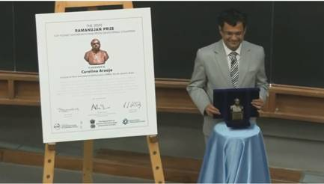

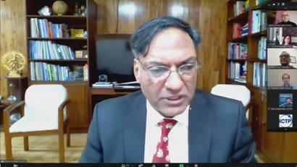

Source
Press Information Bureau, 11 December, 2020

