Dr. Harsh Vardhan inaugurates four pyres of the Green Crematoria,‘Air Pollution Control System for Crematoria’, developed by CSIR-NEERI at Delhi’s Nigam Bodh Ghat Crematorium

Also inaugurates three new Gas-based pyres developed by Indraprastha Gas Limited
Such technology helps to reposition our existing heritage by adopting clear methods for achieving our national and global commitments towards the environment:Dr. Harsh Vardhan
Such innovation can also be applied to mitigate dispersed air pollution emitted from unorganized and informal industrial sectors: Dr. Harsh Vardhan

The Minister of Science & Technology, Earth Sciences and Health & Family Welfare, Dr. Harsh Vardhan today said, “Exceedingly high concentration of air emissions with respect to particulate matter, and other harmful gases have been measured in regions around the crematoria. To address the high localized toxic emissions from crematoria, CSIR-National Environmental Engineering Research Institute(NEERI) has developed a technology knowhow to mitigate air pollution from Open Pyre Green Crematoria’s”.

The Minister was speaking after inaugurating four pyres of the Green Crematoria at Delhi’s Nigam Bodh Ghat Crematorium here.He also inaugurated three new pyres run by Indraprastha Gas Limited.

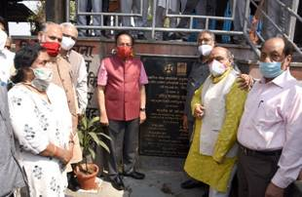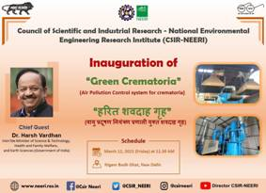
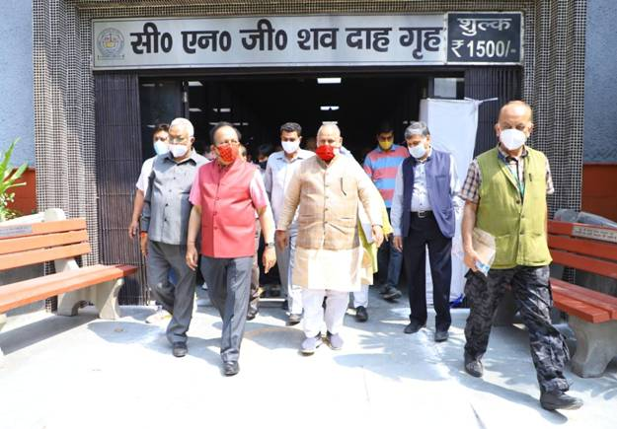
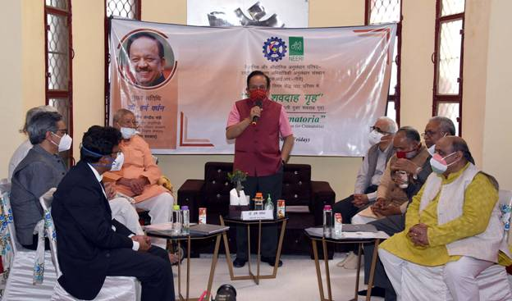
Dr. Harsh Vardhan called for a comprehensive plan for institutionalised ‘Green Good Deed’ at the venue. He said with such green initiatives, a lot can be achieved in improving the air pollution index in the National Capital and scientists from CSIR-NEERI can play a major role in that. He informed that the Central Government has already been working for improving the air quality index in 120 cities across the country.

Dr. Harsh Vardhan highlighted,“Air Pollution has become a grave problem in India with more than 120+ cities falling under non-attainment category as per the National Green Tribunal”. He pointed out, “In the recently announced General Budget 2021, a lot of emphasis has been given to allocate resource to mitigate the growing ambient air pollution related problem in India”.

Delhi has about 56 traditional cremation grounds where Hindus cremate bodies by burning massive piles of firewood in the open, billowing out clouds of black smoke into the sky. The technology installed at VIP Pyre 3,4,5,6 comprises Fume collection and handling, Processing/cleaning, Utilities and Waste Handling systems.The system is designed with an efficient scrubbing system offering reduced emission of smoke, oil/greases, hydrocarbons, and particulates etc., with ease of recycle and disposal of scrubbed liquid and solids.

The Minister pointed out, “Such technology helps to reposition our existing heritage by adopting clear methods for achieving our national and global commitments towards the environment”. He said, “The present emission control system with slight design modifications, can be extended to LPG/CNG and Diesel crematoria to future reduce the emission from these systems”.

Dr. Harsh Vardhan said, “Such innovation can also be applied to mitigate dispersed air pollution emitted from unorganized and informal industrial sectors like bakeries, namkeen making, or application areas, where wood is being utilized as a primary source of energy”. He said, “The system like these should be proliferated, under programmes like NCAP, Swachh and Swasth Bharat Initiatives, across the country to reduce the dispersed emissions generated from crematoria thereby impacting the environment and societal health, at large”.

On the occasion, Dr. Harsh Vardhan also appealed for body and organ donation for research purposes and cautioned that people must never let their guard down and must follow appropriate COVID behaviour.

Dr Shekhar C. Mande, DG, CSIR;Dr Rakesh Kumar, Director, CSIR-NEERI; Shri K VenkataSubramanian, Chief Scientist, CSIR; Dr. Padma Rao, Principal Investigator and Senior Principal Scientist, CSIR-NEERI; Shri Jai Prakash, Mayor, NDMC; and other officials were present on the occasion.

For Technical Detail, Please click here.

Source
Press Information Bureau, 12 March, 2021

