49 innovations in 5 focus areas receive Millennium Alliance Round 6 & COVID19 Innovation Challenge-Awards
“DST currently supports 150 technology business incubators with over 4000 technology startups within these incubators across the country”--Professor Ashutosh Sharma

The Millennium Alliance Round 6 & COVID19 Innovation Challenge-Award Ceremony, which recognized 49 innovative solutions in 5 focus sectors of India, highlighted the necessity of building a highly distributed innovation ecosystem.

Announcing that DST will be soon launching a new program to have highly distributed innovation ecosystem, DST Secretary, Professor Ashutosh Sharma said that to have a startup doing innovation it is important to have networking, support, seed money, prototyping facility and all of these facilities could be provided outside the physical space of incubators.

“DST currently supports 150 technology business incubators with over 4000 technology startups within these incubators across the country, bringing in lots of bright ideas and plans to scale up these numbers. Millennium Alliance, along with the other partners-- organisations like USAID, FICCI, DFID have been strong partners in that journey,” Prof Sharma pointed out.

“The Millennium Alliance shows the significance of the partnership of USAID and Indian Government and how it has broadened to bring other partners as well, each of whom brings something to the table” US Chargé D'Affaires Edgard D. Kagan pointed out. Talking about the Millennium Alliance Round 6 & COVID19 Innovation Challenge-Award, he said that this particular effort is not just about supporting innovations, but also about redoubling support to one of the most critical building blocks of US India relationship of entrepreneurship and exchanges.”

“The Millennium alliance illustrates the way in which all the partners have transferred together expertise in Education, Health, Clean Energy, Water & Sanitation, Agriculture sectors and local innovations to countries in Africa and South Asia. It illustrates how things designed in India through this partnership have a global impact,” Sir Philip Barton, British High Commissioner to India.

In the virtually organised award ceremony organized on August 18, 2020, a total of 49 innovative solutions were awarded with a sum totaling Rs 26 crores for their innovations in 5 focus sectors in India namely Education, Health, Clean Energy, Water & Sanitation, Agriculture and sectors having global focus with pilot projects being run in South Asian and African countries like Nepal, Rwanda, Uganda, Bangladesh, Kenya. Also, 16 innovators were awarded in the category COVID 19 Innovation Challenge. These awarded innovations were selected after a rigorous evaluation process undertaken by FICCI with the help of the program partners and subject matter experts.

The award ceremony was organized in the presence of dignitaries and representatives from its partner organisations -- Department of Science and Technology (DST), Government of India, Federation of Indian Chambers of Commerce and Industry (FICCI), The United States Agency for International Development (USAID), UK’s Department for International Development, Facebook and Marico Innovation Foundation.

Speaking at the ceremony Shri AjaiChowdhry, Chair, FICCI Start-up Committee, and Founder, HCL said, “Millennium Alliance responded to the urgent need of COVID19 innovations by launching a focused call to provide funding to support Indian startups whose technologies could be quickly deployed to mitigate the impact of the pandemic. More than 400 innovators applied for the call within a span of three weeks”.

The Millennium Alliance is an innovation-driven and impact-focused initiative leveraging collaborative resources to identify test and scale Indian innovations that address global development solutions. It is a consortium of partners (Public-Private Partnership) including the Department of Science and Technology, Govt. of India, United States Agency for International Development (USAID), Federation of Indian Chambers of Commerce and Industry (FICCI), UK Government’s Department for International Development (DFID), Facebook and Marico Innovation Foundation. The program is currently running in its sixth year and has played a catalytic role in providing funding, capacity building, and business development support to Indian social enterprises.

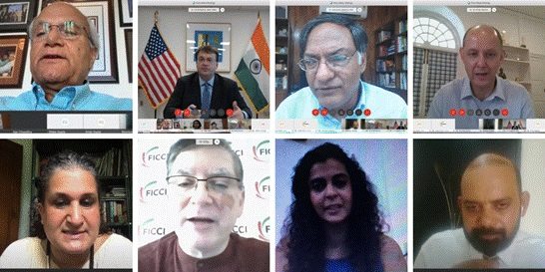

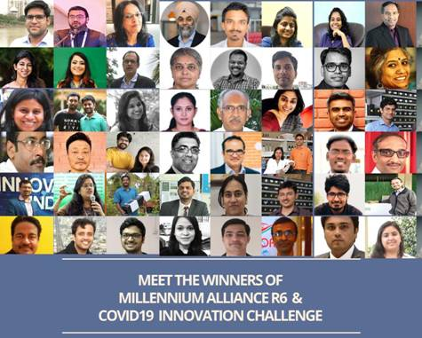

Source
Press Information Bureau, 19 August, 2020

