CSIR-CMERI Celebrates its 79th CSIR Foundation Day

CSIR-CMERI celebrated its 79th CSIR Foundation Day today, with a lot of fervour. Prof. (Dr.) Harish Hirani, Director, CSIR-CMERI, Durgapur, addressed the employees of the Institute through a live webcast on the occasion. In his address, Dr. Hirani urged all to set a benchmark for themselves by defying all sorts pod resistance, so as to ‘Selflessly Serve the Society through dedicated R&D Efforts.’

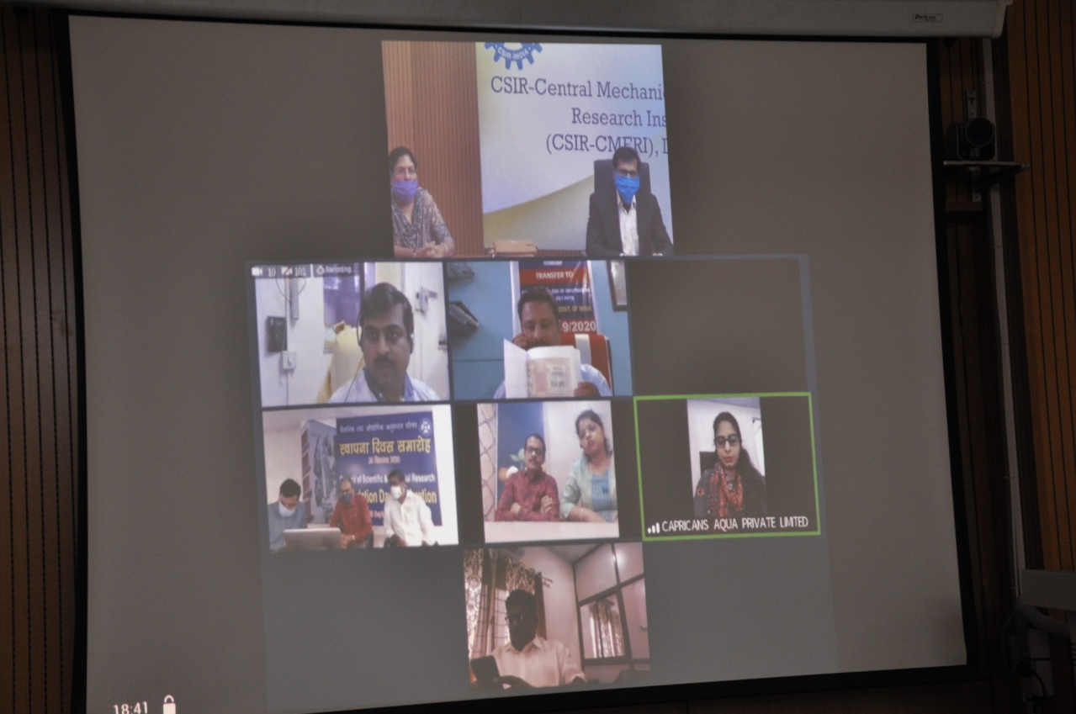

Prof. (Dr.) Hirani in his CSIR Foundation Day address said, “This Institute has strong foundations to excel as an Institute of Global Excellence. All the technologies developed here are thoroughly evaluated before commercialization. CSIR-CMERI is focussed upon improving the Entrepreneurial potential of individuals instead of making them lean towards jobs. Collaboration instead of Competition is the Mantra for the future. Comprehensive Waste Management and Complete Eradication of Manual Scavenging are the two of the few priority objectives for CSIR-CMERI. The CSIR-CMERI technologies besides solving core problems also address issues such as contamination of underground Water and reduction of Water Usage for Agricultural purposes.”

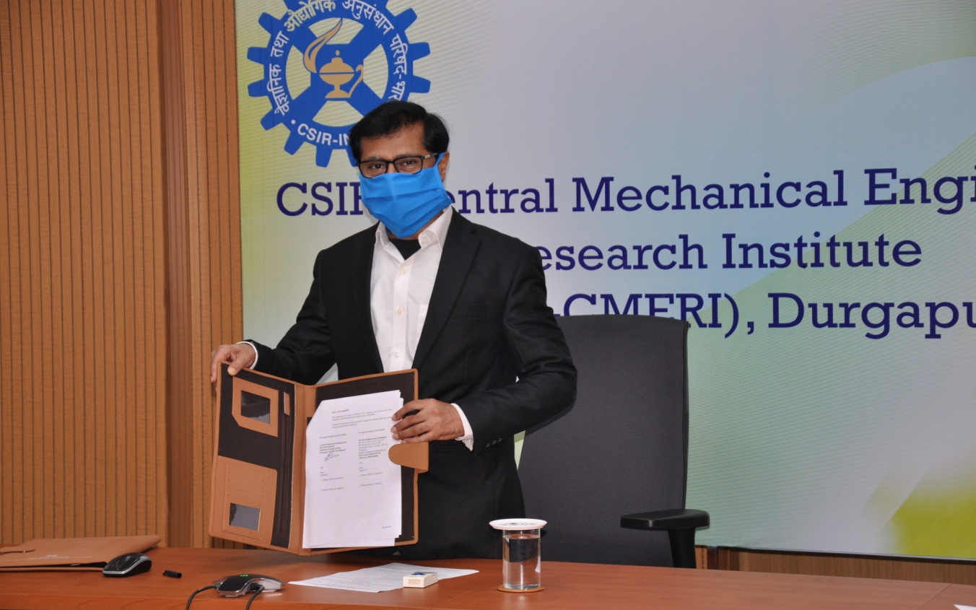

The Director, CSIR-CMERI also presented the recent achievements of the Institute and stated that all the efforts and results of this Institute are in cognisance of the Government as it is striving to reach the vision of our Prime Minister- the Atmanirbhar Bharat. He also made a clarion call for quantification of the purpose of our scientific endeavours which he pointed out, must also have social and innovation factors. He also delivered on the indicators intended to reflect i.e. scientific characteristics, economic characteristics and social characteristics. The future course of the Indian Economy will be decided by the Youth and therefore up skilling the youth will fuel the Nation forward towards being an Economic and Scientific Powerhouse, Prof (Dr.) Hirani opined. Thus, the Skill & Innovation Promotion Group of CSIR-CMERI is relentlessly engaged in providing Skill sets to the Youth and to help them attain knowledge about the rapid strides in Science & Technology made by the Institute, to encourage and inspire them to go beyond the technological achievements of the Institute and further add value onto it. This careful nurturing of the young minds will equip and prepare them to become the Entrepreneurs of Tomorrow, which in turn will drive the Nation’s Future, the Director claimed.

Prof. Hirani talked about the Brand CSIR-CMERI. He highlighted the achievements of the Institute in recent like the world’s largest Solar Tree, Mob Control Vehicle, development of Mechanized Drain Cleaning on-site Waste Water purification technology, Dry Fogging Shoe Disinfector, Solar Chulha, Municipal Solid Waste Disposal System and other solid management system, UV Disinfection devices and Box, Automatic Biodiesel Plant, Automatic Biomass Briquetting Plant, Outdoor Air Purifier, Hospital Care Assistive Robotic Device, work done in water testing etc. He also discussed about the decision to hold an All India Annual Essay Competition by the Institute. For the significant performance of the Institute on the front of the Intellectual Property Rights and generation of cash flow he congratulated the concerned scientists for their achievements.

The Start-Ups and the Micro Industries are the key elements for strengthening the fundamentals of the Indian Economy. Thus, CSIR-CMERI transferred the following four technologies to the following MSEs:

1. Automatic Biomass Briquetting Technology-
Mr.Sudip Halder, Partner, M/s. Dipsam Shakti Pvt. Ltd, Krishnagar, West Bengal, stated that “The technology of Automatic Biomass is a very useful solution towards the problem of stubble burning especially in Punjab, Haryana, UP and Delhi. The machine is simple in operation, low cost and can be operated by a single operator. Apart from straw, other biomass like leaves, saw dust, grass can be converted into briquette. Also, this is in line with the dream of our Prime Minister for making a ‘Swachh Bharat’. I am pretty sure, with this CSIR CMERI developed technology, I shall be able to start the business and reach to the society.”

2. Semi-Continuous Bio-Diesel Technology-
Mr. M Sesha Sai, Managing Director, M/s. Best Engineering Technologies, Hyderabad stated that “With increasing demand of Biodiesel and the present Govt policy of ‘Atma Nirbhar Bharat’, we felt the technology of Semi Continuous Biodiesel Plant is an unique business opportunity for us. This will also create employment generation as well as make a Swachha and Atma Nirbhar Bharat. This technology will provide the solution of import substitution by reducing the burden of import bill and dependence on diesel and LPG.”

3. Contactless Hand Washer-
Dr. Fayaz Ahmad, Director, Bandipora College of Information & Technology, Delhi stated that “The Technology developed by CSIR-CMERI is best suited for institutions, schools, and workplaces as the Contactless hand washer comes with inbuilt storage of 10 litres of liquid soap solution which shall provide safe hand washes as per WHO protocol to more than 2000 persons /students in one soap filling. Moreover, the provision of on-built battery storage makes it very useful to be used in areas like Jammu & Kashmir as there are frequent power cuts and the Technology can work without electricity too.”

4. High Flow-Rate Arsenic Removal Technology-
Mr. Sanjay Datta, Managing Director, M/s. Capricans Aqua Pvt. Ltd, West Bengal on this occasion stated, “The High Flow Rate Arsenic Removal Technology is a cost effective solution for the Arsenic Contamination troubles of the society. The commercialization of the technology will help us reach out to various sections of the society and its people across the Nation. Its deployment at Community Level can also ensure maximum collective benefit.”

The decision to transfer technologies to the Micro and Small Enterprises was undertaken to ensure that the R&D benefits of the CSIR-CMERI developed technologies in the paradigm of Energy, Water and its associated utilities benefits the society across the nation coupled with providing viable entrepreneurial opportunities to the youths and micro & small enterprises.

Source
Press Information Bureau, 26 September, 2020

