CSIR-IMMT celebrates its 57th Foundation Day

Dr. Harsh Vardhan calls for brain-storming by scientists for a new vision, rethinking, redesigning and research for making good change in people’s lives.

The CSIR-IMMT (Institute of Minerals and Materials Technology), Bhubaneswar today celebrated it 57th Foundation Day at a virtual function here.Dr. Harsh Vardhan, Union Minister of Science & Technology, Earth Sciences and Health & Family Welfare was the Chief Guest on the occasion. Dr.Shekhar C. Mande, Secretary DSIR and DG, CSIR was present as the Guest of Honur while Prof. S Basu, Director, CSIR-IMMT, Dr. A K Sahu, Chairman, Foundation Day Celebration Committee and several other scientists, officials and staff members joined the event virtually through video-conferencing.

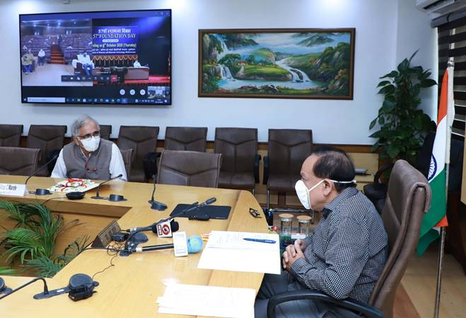

On the occasion, Dr. Harsh Vardhan released the Annual Report 2019-2020 of the Institution (http://events.immt.res.in/relreport/). He also released CSIR-IMMT Video (http://events.immt.res.in/relvideo/) and CSIR-IMMT Theme Song (http://events.immt.res.in/relthemesong/). The Minister also inaugurated CSIR-IMMT Website (http://events.immt.res.in/relwebsite/) and e-Exhibition of the Institute (http://events.immt.res.in/relexhibition/).

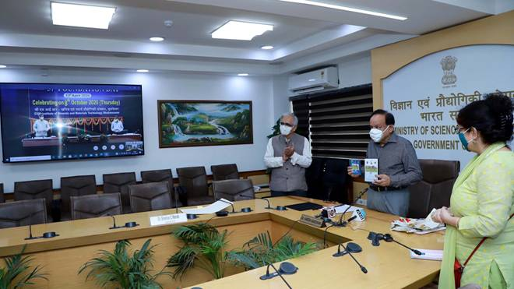

IMMT is a premier national laboratory of the Council of Scientific & Industrial Research (CSIR), New Delhi. The institute is dedicated to harness the potential of minerals, materials and other natural resources of India. Established in the year 1964 as Regional Research Laboratory (RRL) Bhubaneswar, it was renamed as Institute of Minerals & Materials Technology (IMMT) on 13thApril 2007 with a renewed mandate, vision and focus.

Main thrust of R&D at IMMT has been to empower Indian industries to meet the challenges of self-reliance by providing advanced process know-how and consultancy services for commercial exploitation of indigenous natural resources while simultaneously conducting basic research of high calibre in the areas of science and engineering applications.

Dr. Harsh Vardhan extended his greetings to CSIR-IMMT and lauded the efforts of the scientists to scientifically harnessing the waste materials into wealth.He said that science has the capacity to find solutions for every problem faced by humanity. The minister said Indian scientists have always risen to the occasion whenever the situation demanded it. He recalled the great contribution of all scientists in various institutions in coming up with innovative ideas and products to combating Covid-19 in the country.Dr. Harsh Vardhan called for brain-storming by scientists for a new vision, rethinking, redesigning and research for making good change in people’s lives.

Dr.Shekhar Mande highlighted CSIR-IMMT’s contributions towards alleviating people’s problems during super-cyclone Amphan early this year, with its various technologies, especially in water purification etc. He pointed out that IMMT has established a NABL accredited centre of excellence for chemical and biological testing of drinking and industrial water sources. IMMT’s water filtration media, popularly known as “Terafil”, provides a very low cost solution to water treatment technology. He drew attention to the Institution’s role in fighting Covid-19 pandemic situation by developing hospital assistive devices and PPEs which include hands free hand wash and hand sanitization equipment, liquid hand sanitizers, antiviral spray machine to combat pandemic situation. Technologies for these products have been licensed to various MSMEs.

He said, IMMT is leading a multi-lab farm based S&T intervention programme for socio-economic development in the aspirational district Navarangpur of Odisha under RashtriyaKrishiVikasYojna (RKVY).

The institute has started the DSIR funded Common Research and Technology development Hub (CRTDH) in the area of New Materials and Chemical processes. Under this IMMT aims to impart training to MSMEs and Start-ups in the relevant areas for Research & Business.The institute also undertakes programmes to monitor and assess coastal environment and atmospheric pollution round the year. IMMT is collaborating with ISRO in this respect.

Source
Press Information Bureau, 08 October, 2020

