NCSTC-GUJCOST Webinar Series to be organised - Overcoming COVID-19 by Awareness & Preparedness

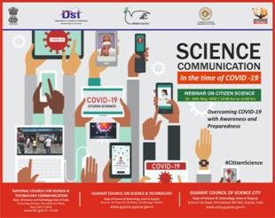

The National Council for Science & Technology Communication (NCSTC), Dept. of Science & Technology, Govt. of India, in association with the Gujarat Council of Science & Technology (GUJCOST), will be organizing a Citizen’s Science Webinar Series on ‘Science Communication in the Time of COVID-19’ during 10-16 May 2020 everyday between 10-11 a.m. The webinar would be accessible online through internet.

The webinar would address ways of tackling the current pandemic by applying various methods and means, an urgent need of the hour. It will develop awareness and preparedness to deal with and address current health crisis posed by COVID-19 to help overcome the situation.

In order to facilitate necessary actions and preparedness of the society to address the challenge, such strategies to reach out to society with the necessary information by involving various stakeholders, including students, academics, media and volunteers,and so on, would be an advantage.

Communication of associated risks through effective science popularisation for promoting community-level response will help translation and usage of authentic scientific and health information and facilitate crisis management.

Source
Press Information Bureau, 7 May, 2020

