Rural Women from Assam prepare products like hand sanitizer, homemade mask to combat COVID19
Rural Women Technology Park (RWTP) under CSIR-North East Institute of Science and Technology, Jorhat, Supported by SEED Division, Department of Science and Technology (DST), have engaged rural women to prepare various products such as hand sanitizer, homemade mask, and liquid disinfectant to be distributed freely among family members and poor people in the nearby village to help combat COVID 19 in the area.

"Meeting a challenge such as COVID-19 needs strong community participation and support. Self-help groups and dedicated NGOs are perfect vehicles in the current scenario for awareness creation, introducing relevant solutions, making and distributing the low tech items such as masks and disinfectants", said Professor Ashutosh Sharma, Secretary, DST.

Rural women from the region were trained to produce homemade mask from traditional ‘Gamocha’ (a traditional Assamese cotton towel) by RWTP, Jorhat. Design of the home made mask has been finalized, around 150 Gamochas purchased and two sewing machines arranged (6 homemade masks can be prepared from one Gamocha).

It has been proposed that the women be paid at the rate of Rs.15/- per mask.. Apart from this, 200 liters of liquid disinfectant is being produced. The raw materials required for liquid disinfectant like dettol, ethanol, glycerine, essential oil have been acquired. The disinfectant will also be distributed freely among the family members and poor people in the nearby village.

The women of RWTP were trained before closing down on March 24. The participant women prepared about 50 litres of hand sanitizer, 160 litres of liquid disinfectant which have been distributed among the 60 women participants and their family members. The RWTP also prepared posters and leaflets on ‘COVID19 : Do’s and Don’ts’ in Assamese language for making people aware about the Corona Virus and precautionary measures to be taken during the present situation.

[For more details:
- Mr Jatin Kalita, Principal Scientist, CSIR-NEIST, Jorhat, Email: kalitajk74@gmail.com, Mob: +91-9435557824
- Dr Indu Puri, Scientists ‘F’, DST, indub.puri@nic.in, Mob: 9810557964]

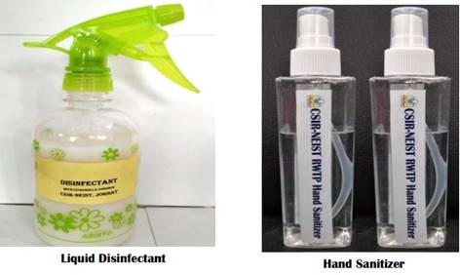

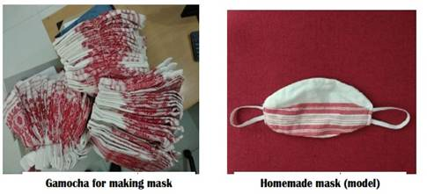

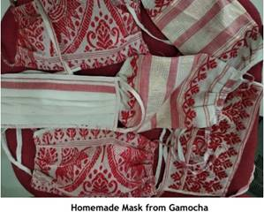

Source
Press Information Bureau, 13 April 2020

