Novel recipe for fabrication of Transparent Conducting Glass can bring down cost of smart windows, touch screens, solar cells

In recent years, the demand of transparent conducting glasses (TCG) with high light transparency has tremendously increased due to its wide range of applications in optoelectronic devices such as smart windows, solar cells, touch screen/ touch sensors, and so on.

Recently scientists from Centre for Nano and Soft Matter Sciences (CeNS), Bengaluru an autonomous institute of the Department of Science & Technology, Government of India have developed a novel recipe for fabrication of TCG which brings down its production cost by 80% compared to tin-doped indium oxide (ITO) based technology which is currently in use. Their current work has been published in the journal Materials Chemistry and Physics.

Industrially relevant TCG came up with conducting coatings such as tin-doped indium oxide (ITO) with a few hundred nanometres of thicknesses, where significant cost is attached to the slow deposition rates adopted for high-quality films.

The newly fabricated TCG consists of metal mesh on a glass substrate with thin overlayers of metal oxides. The design is attractive as the hybrid electrode possesses the excellent conductive property of the metal mesh (having a sheet resistance of about 5 ohms/square) while offering an oxide surface finish for the conductive glass, which makes it relate well with the existing industry requirements based on ITO.

The team lead by Prof. G U Kulkarni, along with his co-workers from CeNS and industrial partner Hind High Vacuum (HHV) Pvt. Ltd. have set-up a semi-automated production plant funded by DST-Nanomission in CeNS-Arkavathi campus for production of low-cost TCG.

Dr. Ashutosh K Singh, Scientist-C at CeNS who is working on this project, said, “We are fabricating various prototypes such as transparent heaters, transparent Electromagnetic Interference shields, smart window, etc. based on TCG to showcase its potential applications. Further, these electrodes have been sent out for field tests in various industries and R&D laboratories”.

These TCGs have been exhibited in various prestigious meetings and conferences such as Bengaluru INDIA NANO-2018 & 2020, ICONSAT-2018 & 2020, SPIE-2019, etc. for dissemination and marketing purpose and are also available for onsite testing and validation purposes.
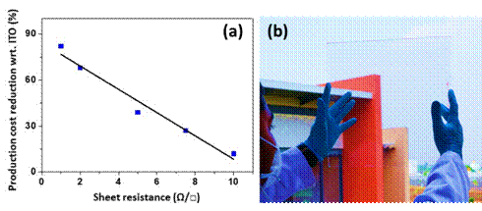
Figure 1 (a) Reduction in the production cost of hybrid electrode wrt. ITO in (%) with sheet resistance values, (b) digital image of hybrid transparent electrode demonstrating its transparency and clarity.
Thus, the TCG developed by CeNS have the potential to bring down the overall production cost of devices like smart windows, touch screens, solar cells, and so on due to its low-cost processing cost.

(Publication details:Ashutosh K. Singh, R. K. Govind, S. Kiruthika, M. G. Sreenivsasn, and G. U. Kulkarni, “Hybrid transparent conducting glasses made of metal nanomesh coated with metal oxide overlayer,” Materials Chemistry and Physics, 239, 121997 (2020)

DOI: https://doi.org/10.1016/j.matchemphys.2019.121997

For more details, Dr. Ashutosh K Singh (aksingh@cens.res.in) can be contacted).

Source
Press Information Bureau, 06 June, 2020

