TDB approves support for indigenous company for ramping up production of COVID-19 diagnostic kits

Real-time PCR based molecular diagnostic kit that screens and detects COVID 19 from samples of flu-like symptoms.

The Technology Development Board (TDB), a statutory body of the Department of Science and Technology (DST), has approved financial support to MyLab Discovery Solutions, Pune, for ramping up production of COVID-19 diagnostic kits they have developed.The company has submitted an application in response to its invitation for proposals for technologically innovative solutions towards fighting COVID-19.
Mylab Discovery Solutions is the first indigenous company to develop real-time PCR based molecular diagnostic kit that screens and detects COVID 19 from samples of people who display flu-like symptoms. With support from TDB, they will ramp up the production of the kits through automation of the facility from current manual process, thereby increasing its current capacity from 30000 tests per day to one lakh test per day. The company is expected to complete the automation within the next few months. This kit has been approved by ICMR and CDSCO. The kit will be deployed in a very short time, considering the national emergency.
TDB invited applications from Indian companies and enterprises to strengthen the nation’s core capacities in surveillance, infection prevention, control, laboratory support, and in particular, the preparedness in terms of isolation and ventilator management of critically ill patients for containing, preventing the spread of COVID-9 on March 20, 2020. TDB’s mandate is to provide financial assistance to private limited companies for the commercialization of Indigenous technologies. MyLab was one of the companies responding to the invitation.
The aim of this call was to strengthen the nation’s core capacities in surveillance, infection prevention/ control, laboratory support, and in particular, the preparedness in terms of isolation and ventilator management of critically ill patients for containing/ preventing the spread of COVID-9. As the critical need of the hour is to escalate testing, isolation and contact tracing so that the chain of spread can be broken, TDB has processed the first set of proposals related to these categories on priority, and the support was finalised after a stringent evaluation process involving experts from government and academic institutions like IITs, IISc, AIIMS, ICMR, DST, and DBT.
Professor Ashutosh Sharma, Secretary DST & Chairman TDB, expressed, “Work in the times of virus has taught us an unprecedented intensity of purpose achieved with speed, efficiency, and quality, which should become the new normal post-COVID-19. Having a team of young professionals with energy and expertise always works!”
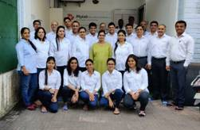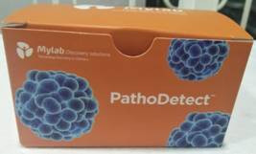
M/s MyLab Discovery Solutions, Pune

[For more details, Cdr Navneet Kaushik, Sc &#39;E&#39;, Technology Development Board, navneetkaushik.tdb@gmail.com , Mob: 9560611391]

Source
Press Information Bureau, 21 April 2020

