Institute- Industry collaboration to boost development of devices for osteoarthritis & diabetic foot ulcer
Development of orthotic devices may soon receive a boost with a Kerala based scientific institution collaborating with a Mohali based private manufacturer for co-development of such devices catering to clinical conditions such as osteoarthritis and diabetic foot ulcer.

Sree Chitra Tirunal Institute for Medical Sciences and Technology, Trivandrum, Kerala (SCTIMST), an Institute of National Importance under the Department of Science and Technology, Government of India, has signed an MoU with Tynor Orthotics Private Limited (Tynor), Mohali, to set up an Orthotics and Rehabilitation R&D vertical to promote indigenous device development in this sector towards the goal of ‘Aatmanirbhar Bharat’, a high priority target of the Govt of India.

Tynor, a manufacturer and exporter of high quality and affordable orthopedic appliances and fracture aids in India, will collaborate with SCTIMST for the co-development of Orthotic devices and to promote joint research programs in Orthotics and Rehab. Tynor has funded SCTIMST for Research and Development of two off-loading devices in patients with diabetic foot ulcers and osteoarthritis. The project is planned for one year with Tynor contributing INR 27 lakhs to the program.

The main objective of this Institute-Industry collaboration is to develop a cluster of orthoses for catering to clinical conditions such as osteoarthritis and diabetic foot ulcer. Asia Pacific is anticipated to witness a lucrative growth in global diabetic foot ulcer therapeutics market owing to the increasing geriatric population, which is more prone to diabetes. Global Diabetic Foot ulcers and Pressure ulcer Market is expected to reach 5265 Million Dollars by 2025 with a compound annual growth rate(CAGR) of 6.6% from 2019-2025, which is quite alarming.

Similarly, the global knee braces market is growing due to the rising prevalence of osteoarthritis, increasing number of orthopedic knee surgeries, and growing number of sports injuries in athletics. The global knee braces market size was estimated at USD 1.5 billion in 2018 and is expected to witness a CAGR of 4.3%. The growing burden of osteoarthritis, the increase in target population, and the technology of cost-effective and easy to wear braces are the major growth propellers for the market.

SCTIMST has done considerable amount of R&D work in biomedical devices over the last 30 or more years and has established itself as a pioneer in this field. This collaboration with an Industry leader for co-development of ortho-rehab devices in the country is a commendable step.

Tynor has planned to set up India’s first R&D Center in Orthopedic Appliances, Fracture Aids, Walking Aids, Compression Garments, and Footcare Products. This center has been named TORNADO (Tynor Ortho Research N Appliance Development Organization) and aims to bring about technology and innovation-based disruption at the scale of a tornado. This will be a novel center in which a Cross-Functional Team consisting of experts from Engineering, Orthopedics, Biomedical Sciences, Design shall be brought together to brainstorm and develop products as per the requirements of the Indian patient. Industry-academia collaboration is the key to achieve this feat.
Scientists from the Biomedical Technology Wing of SCTIMST, Mr. Subhash NN, Mr. Muraleedharan CV, and Dr.HarikrishnaVarma (Head BMT Wing) are driving the Orthotics and Rehabilitation R&D vertical along with Clinicians from the hospital wing Dr. Nitha J and Dr.SubinSukesan, and other experts of the country as advisors.

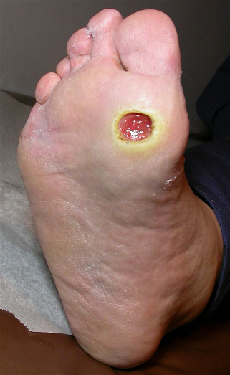
Figure 1. Diabetic foot ulcer

Figure 2. Knee brace

Source

Press Information Bureau, 16 September, 2020

