A Rapid Response Regulatory enabling mechanism facilitated by Department of Biotechnology for COVID 19

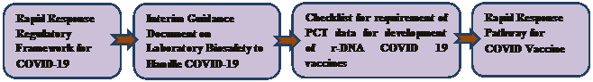

The Department of Biotechnology has taken several proactive measures to streamline the biosafety regulation and to facilitate researchers and industries which are undertaking research and development in Recombinant DNA Technology and Hazardous Microorganisms.
1. Operationalization of Indian Biosafety Knowledge Portal. The Indian Knowledge Biosafety Portal launched in May, 2019 was made fully operationalized and now the Department is receiving all new applications through online portal only. This has made the whole process transparent and time bound.
2. Notification of Revised Simplified Guidelines on Import, Export and Exchange of GE Organisms and Product Thereof for R&D Purpose: The Department issued the Revised Guidelines in January, 2020 in which Institutional Biosafety Committee have been delegated authority to take decisions on applications of import export and exchange of GE organisms and product thereof for R&D purpose for RG1 and RG2 items.
3. Facilitation of Research and Development on COVID-19: Considering the emerging situations of spread of Coronavirus and with the understanding on requirement of rapid research and development for COVI-19, the Department has proactively taken several steps to facilitate researchers and industries involved in research on COVID19. DBT has issued following guidelines, orders and checklist on COVID 19:

- Rapid Response Regulatory Framework for COVID-19 to deal with application for development of vaccines, diagnostics, prophylactics and therapeutics has been notified on 20.03.2020
- DBT notified “Interim Guidance Document on Laboratory Biosafety to Handle COVID-19 Specimens” on 08.04.2020.
- IBSCs are allowed to conduct their meeting through video conferencing up to 30thJune, 2020.
- Rapid response regulatory framework for development of recombinant DNA COVID 19 vaccine was issued on 26.05.2020.
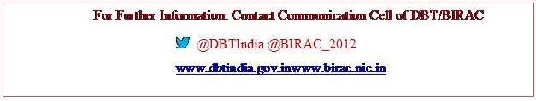

Source
Press Information Bureau, 30 May, 2020

