Technology based startups played a crucial role in converting India from importer to second largest manufacturer of PPEs
A range of low cost innovative technologies developed and scaled up by start-ups from different corners of the country played a crucial role in India emerging globally as a the second largest Personal Protective Equipment (PPE) manufacturer in the world’s battle against COVID 19.
PPEs like masks, face shields especially those used by medical professionals as protection from infection as they tackle the health emergency is a crucial shield in the battle against COVID 19. India had been importing PPEs at the start of the pandemic period, but a range of technologies like affordable mask making machines, low cost masks, reusable anti-viral and anti-bacterial masks, safety masks specifically designed for health workers by start-ups helped the country to turn the tables and start exporting them.
Many of these start-ups were supported by the Department of Science and Technology under the Centre for Augmenting WAR with COVID-19 Health Crisis (CAWACH) initiative by National Science & Technology Entrepreneurship Development Board (NSTEDB).
Saral Design Solutions a Mumbai based company that had earlier developed the world’s first fully automatic sanitary napkin making machine to produce these essentials locally, repurposed their machine to make3 ply surgical masks.
The fully automatic 3 ply mask making machine called SWACHH enables production of mask locally and hence obviates the necessity of transportation. It produces high quality South India Textile Research Association (SITRA) certified masks with Spunmelt (SSMMS) based filter and nose wire at very low cost and employs local people in the process.
Mahindra Group took the machine to their plant and started manufacturing masks during the lockdown and leveraged its supply chain to meet the urgent requirement of masks. This was a classic example of startup-corporate collaboration that combined the agility and innovation of startup that was scaled up by corporates to cater to the needs of the time.
About 1.4 million masks produced by their innovation have been donated as part of CSR as well as through crowdfunding campaigns to frontline workers such as doctors, police, nurses and district health departments. One of the machines has been set up in Bhiwani, Haryana, with the help of DST CAWACH grant. Masks produced from this machine are being distributed to frontline workers in areas surrounding states of Haryana.
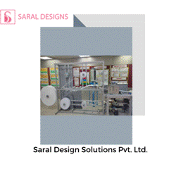

Printalytix Private Limited from Bengaluru has developed three products for protection against infection -- protective face shields, contactless door opener and intubation boxes. In association with HTIC-IITM, Chennai the company has accelerated the production of these and achieved the scale to meet the market requirements and upgrading affordability, quality and functionality of products. The CAWACH funding and association with HTIC-IITM, has helped the company validate their products design and accelerate manufacturing in large volumes using existing MSME network and supply chain and successful deployment among the target user base.

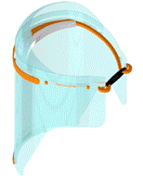

Face shields

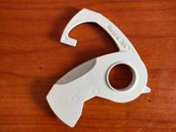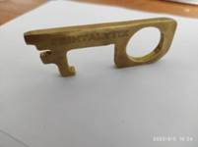

Contactless Stylus

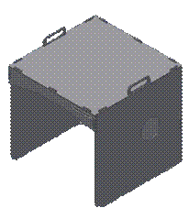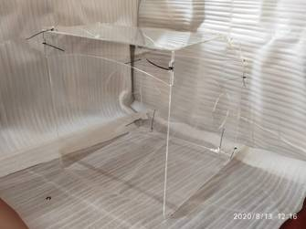

Intubation Box
Nasal or oral swabs needed to test COVID 19 patients are collected in open air or using telephone booth model during COVID-19 pandemic. Open-air sample collection exposes healthcare practitioners, their immediate work environment and PPE kits to harmful virus carrying droplets. On the other hand telephone booth type model is not suitable for all clinical settings. To help medical professionals collect oral swabs without infecting themselves, ComofiMedtech has developed theNT-Mask which is a transparent N95 mask with special access point that provides contactless nasal or oral swabs collection.
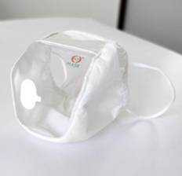
The startup scaled its NT-Mask production in two months and is currently manufacturing 1000 Mask sper day. The mask complies with required parameters like splash resistance pressure, Breathability, and Bacterial filtration efficiency. It has been tested and validated by NABCB accredited lab.
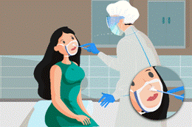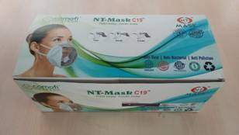

Nanoclean Global based in New Delhi has developed Nasomask, N95/FFP2 grade face mask using nanofibers which is highly efficient against contagious viruses has high breathability and negligible breathing resistance.
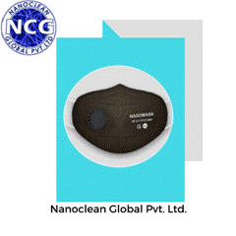
The start-ups have been hand held at different stages by SINE IIT Bombay which is the implementation partner for the CAWACH program. In addition, other eight incubation centres Indian STEPs and Incubators as well as supporting satellite centres identified from different zones across India like FIIT, IIT Delhi, SIIC, IIT Kanpur, HTIC, IIT Madras, Venture Centre, Pune, IKP Knowledge Park, Hyderabad, KIIT-TBI, Bhubaneswar have lent a helping hand to the start-ups at different stages.

Source
Press Information Bureau, 31 December, 2020

