IHBT scientists develop new sanitizer

Natural flavours, active tea constituents and alcohol content in this hand-sanitizer have been used as per the guidelines of the World Health Organization (WHO)
Chemicals like parabens, triclosan, synthetic fragrance and phthalates have not been used in this product

Demand for products such as sanitizer is increasing amidst reports of preventive measures against coronavirus and many counterfeit materials being sold in the market. In view of this, a new hand-sanitizer has been developed by the scientists of CSIR-Institute of Himalayan Bioresource Technology (CSIR-IHBT) based in Palampur, Himachal Pradesh.
Dr. Sanjay Kumar, Director of IHBT stated that “The natural flavours, active tea constituents and alcohol content in this hand-sanitizer have been used as per the guidelines of the World Health Organization (WHO). One of the special things is that chemicals like parabens, triclosan, synthetic fragrance and phthalates have not been used in this product. ”
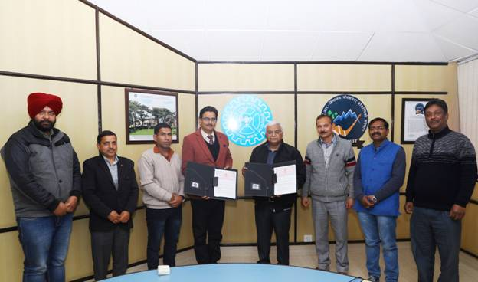
The technology has been transferred to Palampur based company M/s A.B. Scientific Solutions for the commercial production of this newly developed hand-sanitizer. An agreement has been signed between CSIR-Institute of Himalayan Bioresource Technology (CSIR-IHBT) and the company.
The company, which has a strong nationwide marketing network of its own, will be establishing a facility in Palampur for the commercial production of hand-sanitizer. The company will also market these hand-sanitizers and other disinfectants in all major cities across the country.

Dr. Sanjay Kumar says that due to the sudden increase in demand for sanitizer in the market, its arbitrary prices are being charged. In the view of current increase in demand for the right product, this hand sanitizer has been developed at an appropriate time.

Source

Press Information Bureau, 18 March 2020

