DST collaborates with IBM to build STEM career opportunities for girl students

Collaborations to scale up two DST initiatives--Vigyan Jyoti and Engage with Science (Vigyan Prasar)
Scaling up of the interactive learning platform ‘Engage with Science’ will make learning relevant and foster scientific spirit among the country’s youth: Professor Ashutosh Sharma, Secretary DST
Existing opportunities for meritorious girls to nurture their interest in Science Technology, Engineering, and Mathematics (STEM) will be expanded and a learning platform scaled to make learning relevant and foster scientific spirit among the country’s youth in partnership with IBM.

The Department of Science & Technology (DST) and IBM India announced collaborations to scale up two DST initiatives--Vigyan Jyoti and Engage with Science (Vigyan Prasar), on October 8, 2020.

Vigyan Jyoti is a programme to promote STEM learning among girl students and to inspire them towards STEM careers by creating a level-playing field for meritorious girls from grades 9 to 12 to pursue STEM in their higher education, especially from the top colleges in the areas where girls are hugely underrepresented.

Engage with Science of Vigyan Prasar is another initiative to build interest and create a community of practice with students, teachers, and scientists connecting the high school students to the higher education institutions.

Announcing the collaborations Professor Ashutosh Sharma, Secretary DST, said, “The partnership with IBM will make these programs of DST and Vigyan Prasar reach the students and teachers in interactive ways on a large scale. Scaling up of the interactive learning platform ‘Engage with Science’ will make learning relevant and foster scientific spirit among the country’s youth, it would address the school students directly who need more knowledge outside the classroom and provide insights into an interactive way of learning, thus helping sift the useful from the useless.”

“The engage with Science platform will make students interact, participate and get involved with the sampling and active consumption of S&T content, including Cloud, Big Data, etc. through the usage of digital tools,” he added.

“Vigyan Jyoti initiative by DST focuses on solving the multidimensional problems associated with meager representation of women in Engineering and Technology streams in higher education by building confidence and excitement towards these streams. In 5 years from now, we want to see the proportion of girl students enrolled in engineering and technology streams increasing to one-third of the total,” Professor Ashutosh Sharma pointed out.

The Vigyan Jyoti programme was launched by DST in 2019 to inspire girl students to pursue higher education and career in STEM fields. The program provides a scholarship, visit to nearby scientific institutions, science camps, lecturers from eminent women scientists, and career counseling. The program is currently implemented by Jawahar Navodaya Vidyalaya (JNV) in 58 districts, with the participation of about 2900 students. The partnership with IBM India will strengthen the current activities and expanded to include more schools in the future. Women tech experts working at IBM India will interact inspire girl students to plan for a career in STEM under the program. This will strengthen the DST’s initiative to increase the number of women in technology fields.

“It is the need of the hour to promote gender diversity in STEM education and to create new avenues for cultivating diverse talent. The collaboration with DST will expand our STEM program to girl students pursuing 10+2 courses,” said Mr. Sandip Patel, MD, IBM I/SA.

DST and IBM India aim to create a robust STEM ecosystem that nurtures critical thinkers, problem-solvers, and next-generation innovators through Inspire Awards-MANAK (Million Minds Augmenting National Aspirations and Knowledge) – a program targeting to build one million ideas rooted in science from school students. DST and IBM India will work together to further integrate and develop Science & Technology in the education ecosystem with short term courses, workshops, mentoring, and online science content communication for teachers and students in India.

In the other collaboration launched alongside, IBM will work with Vigyan Prasar – an autonomous body under the DST to help India’s science popularization agenda through several strategic initiatives, including ‘Engage With Science’. This is an interactive platform that will be built on top of the India Science Over-The-Top (OTT) platform to encourage and inspire high school students to pursue Science & Technology (S&T) for a career. As part of the collaboration, IBM will run the day-to-day activities of the program, including student workshops, seminars, and leverage its expertise to mentor the students. The platform will make students interact, participate and get involved with the sampling and active consumption of S&T content, including Cloud, Big Data, etc. through the usage of gamification tools and AI/ML components.

‘Engage With Science’ will actively engage with schools, shoot interactive programmes in the school premises, provide windows of recognition, and glorification to select teachers of S&T subjects. The programmes, when aired on India Science channel, shall, in turn, create a fan following and community creation around teachers and schools.

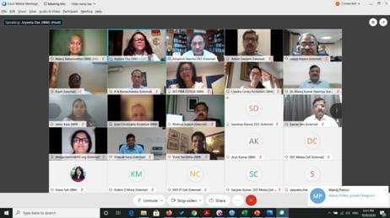
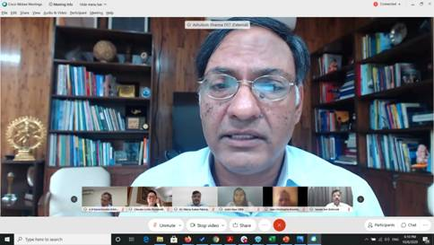

Source
Press Information Bureau, 09 October, 2020

