Present & former DST Secretaries discuss DST’s roadmap in transforming India
Secretaries--both former and present, of the Department of Science and Technology (DST) highlighted the milestones achieved so far by DST and discussed the road ahead at the inaugural panel discussion on ‘Remembering 50 Golden years of DST’ organized to commemorate the golden jubilee celebration of the department.

“DST has an extraordinary impact on the S&T ecosystem in the country. DST’s reach and depth in every area is huge, making it truly the agency for transformation of India through Science & Technology,” said former DST Secretary and present Principal Scientific Adviser (PSA) to the Government of India, K VijayRaghavan said in the panel discussion which was part of DST Golden Jubilee Discourse series.

“For India, the approach to catch up with other global leaders in science should be to do more for less and use the intellectual capacity to do so. It has to be proportionate to our investment in terms of GDP. Looking at various themes of technology, India also has to see whether there is room for originality that could make it valuable for us in terms of investment,” he added, chalking out a way forward.

DST Secretary Professor Ashutosh Sharma pointed out that the establishment of DST has been a turning point for science, technology, and innovation in India and connected to a very wide stakeholder base of S&T in India all the way from school students to Ph.D. to young scientists, R&D labs, Universities, and colleges.

He elaborated about some of the great institutional structures built by DST -- the Technology Development Board (TDB) responsible for commercializing indigenous technologies and the Science and Engineering Research Board (SERB), which has empowered several scientists. He added that all the deep foundations built so far and human resources built over 5 decades can be activated with speed and scale, as seen during the COVID 19 pandemic.

Professor T Ramasami, former Secretary DST (2006-2014), underlined that DST has played the role of pranavayu or the oxygen for the Indian Science system. “Given that science is ultimately to be celebrated by the citizens of the country, DST should look at the opportunity today that India presents of a completely new S&T policy framework to reach the unserved and underserved people of the country,” he added.

Prof. VS Ramamurthy, former Secretary DST (1995-2006), sharing his memories of DST said, “We established the first Technology Business Incubator outside any educational institution, and now this year 100 more such incubators will be set up by DST. This is a scale in which we would like to move.”

“We need enough number of researchers and technologists consistent with our population. COVID times have shown us our technological strength come to life and deliver in times of need. This will take us forward,” he stressed.

The discourse series, a part of a chain of programmes for the 50 years celebration of the department was organized virtually by the National Council for Science & Technology Communication (NCSTC), a division of the Department of Science and Technology, Government of India, and Vigyan Prasar.

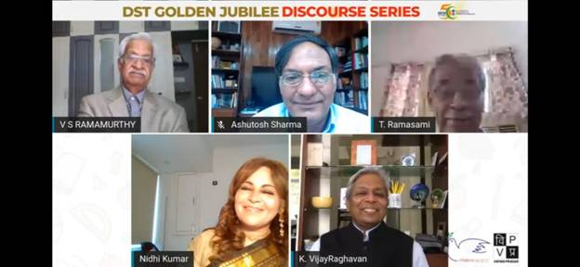

Source
Press Information Bureau, 2 September, 2020

