SCTIMST scientists develop disinfection gateway & facemask disposal bin to fight COVID-19
Professor Ashutosh Sharma, Secretary, DST asserts, "Disinfection of people, garments, surfaces and used disposable protective gears are vital to break the chain of transmission”

Scientists at Sree Chitra Tirunal Institute for Medical Sciences and Technology (SCTIMST), Trivandrum, Kerala, an autonomous institute under the Department of Science and Technology (DST), Government of India, have designed two technologies to fight COVID-19 pandemic.
Chitra Disinfection Gateway is one of the two technology designed by SCTIMST scientistsJithin Krishan and Subash VV from the Division of Medical Instrumentation for the decontamination of people, one at a time. It is a portable system equipped with a system for generating Hydrogen peroxide mist and UV based decontamination facility.
Hydrogen Peroxide fumes will decontaminate the body, hands, and clothes of a person. The UV system will decontaminate the chamber.The whole system is electronically controlled. The sensors mounted in the chamber will detect the entry of a person and start the Hydrogen Peroxide mist generation process.The person is required to walk through the chamber to its end. When the person exits, the system will shut off the hydrogen peroxide fumigation system and will turn on the UV lamp inside the chamber to decontaminate it. After the UV light is switched offautomatically after a prescribed time, the chamber is ready for the next person. The whole process takes only 40 seconds.The system has see-through glass panels on sidewalls for monitoring and is fitted with lights for illumination during use. The design and Know-how have been transferred to HMT Machine Tools, Ernakulam, Kerala.
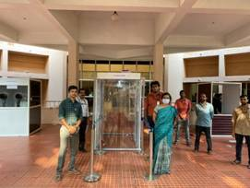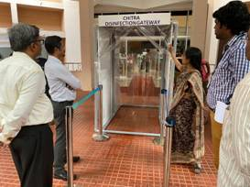
The second technology,Chitra UV Based Facemask Disposal Bin designed by Subash VVfrom SCTIMST, is a UV Based Facemask Disposal Bin. The ‘UV Based Facemask Disposal Bin’ can be used by health workers in hospitals and in public places where decontamination of used facemask, overhead covers, face shields,and so on are required to break the infection chain.
Face masks are a must-have item due to the current Covid-19 outbreak, but the used masks are hazardous waste and must be disposed of properly. The waste collectors are at risk of being exposed to COVID19 while performing their duties. Instead of just throwing used face masks into the waste bin, disinfecting the used mask is a must. The Design and Know-how transferred to HMT Machine Tools, Ernakulam, Kerala.
Professor Ashutosh Sharma, Secretary, DST said, "Disinfection of people, garments, surfaces and used disposable protective gears are vital to break the chain of transmission. The use of hydrogen peroxide spray and ultraviolet light in appropriate doses are two robust weapons in this fight, both of which are used in the innovations being discussed here."

(For more details, please contact: Ms. Swapna Vamadevan, PRO, SCTIMST, Mob: 9656815943, Email: pro@sctimst.ac.in)

Source

Press Information Bureau, 10 April, 2020

