Prime Minister Shri Narendra Modi inaugurates India International Science Festival-2020 in the presence of Dr Harsh Vardhan

India has data, demography, demand, democracy to achieve world class scientific solutions: PM
We want our scientific community to share and grow with the best of global talent: PM
The Prime Minister gives a call to the global community to invest in Indian talent and innovate in India.

IISF-2020

The India International Science Festival (IISF)-2020 got off to a grand start with the inaugural address by the Prime Minister, Shri Narendra Modi in the presence of Minister of Science & Technology, Earth Sciences and Health & Family Welfare, Dr Harsh Vardhan. This year’s festival is being organised in a virtual mode and is being held from 22-25 December, 2020.

Addressing on the occasion on virtual mode, the Prime Minister said that this Festival is a celebration of science and added that India has a rich legacy in science, technology and innovation. Our scientists have done path breaking research. Our tech industry is at the forefront of solving global problems. But, India wants to do more. We look at the past with pride but want an even better future, Shri Modi said.
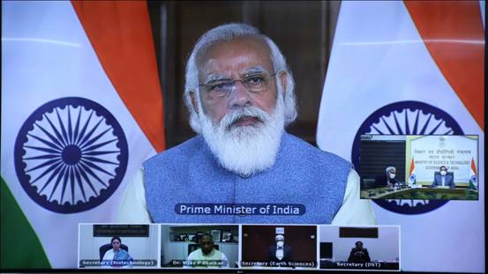
The Prime Minister said all our efforts are aimed at making India the most trustworthy centre for scientific learning. At the same time, we want our scientific community to share and grow with the best of global talent. One of the steps taken to achieve this is hosting and participating in hackathons to provide exposure and opportunity to Indian scientists.
The Prime Minister asserted that the New National Education Policy will help in fostering scientific temper from an early age. He said now focus has shifted from outlays to outcome, from textbooks to research and application. The Policy will encourage creation of a pool of top quality teachers. This approach will help the budding scientists. This is being supplemented by Atal Innovation Mission and Atal Tinkering labs, Shri Modi said.
For Quality research, the Government is running Prime Minister Research Fellows Scheme to encourage the best talent of the country to undertake research as per talent and interest. The Prime Minister informed that the scheme is helping scientists in the top institutes.
The Prime Minister emphasized the importance of bringing the benefits of science and technology to all. He said that Science and Technology are bridging the gap of scarcity. It is connecting the poorest of the poor with the government. With digital advances, India is becoming a centre of evolution and revolution of global high-tech power, the Prime Minister added.
To achieve this world class education, health, connectivity and rural solutions, today’s India has data, demography and demand. Above all, India has democracy to balance and protect all this. That is why the world trusts India, the Prime Minister stressed.
The Prime Minister said there are many challenges in our country like Water Scarcity, Pollution, Soil Quality, Food Security, for which modern science has a solution. Science also has a big role in rapidly exploring the water, energy and food resources in our sea. He said India is running Deep Ocean Mission for this and has achieved success. He said the benefit of new inventions in science finds a way in commerce and business as well.
The Prime Minister said reforms have now been undertaken in the Space Sector to encourage our youth and the private sector to not only touch the sky, but also the heights of the deep space. He said the new Production Linked Incentive Scheme also focuses on sectors related to science and technology. Such steps will give a boost to the scientific community, the ecosystem related to science and technology will get better and generate more resources for innovation and create a new culture of partnership between science and industry. He wished that this festival would give new dimensions to the Spirit of Coordination and Collaboration between Science and Industry as new collaborations will lead to new avenues.
The Prime Minister stressed that the biggest challenge facing science now, may be a vaccine for COVID pandemic. But the biggest long term challenge science faces is to attract high quality youngsters and retain them. He further added what is called science today, becomes the technology of tomorrow and an engineering solution later. He said for attracting good talent into our science domain, the government has announced scholarships at various levels. But it needs a big out-reach from within the science community as well. He said the excitement surrounding Chandrayaan Mission was a great starting point to evince interest from youngsters.
The Prime Minister gave a call to the global community to invest in Indian talent and innovate in India. He told the gathering that India has the brightest minds, and celebrates a culture of openness and transparency. The Government of India stands ready to address any challenge and improve the research environment here. He said Science brings out the best within the person and uses the power of difference. He lauded our scientist for keeping India ahead and in a better position in the fight against Corona.
Pl click here for Full text of Prime Minister’s Speech
Earlier, Dr. Shekhar C. Mande, Secretary DSIR and DG, CSIR, in his welcome address dwelt upon various dimensions of the IISF-2020. He said more than 40 science laboratories and educational institutions are participating in organising this festival and elaborated on the purpose of the IISF-2020. He said, IISF-2020 will attempt 5 Guinness Book of World Records, one of which---maximum students making the Sun Dial simultaneously—was attempted this morning where 6,874 students from 189 schools participated and that the video evidence by representatives of GBWR has been collected and forwarded to them for evaluation and certification.
Those who attended the inaugural included Prof. Ashutosh Sharma, Secretary, DST; Dr.RenuSwarup, Secretary, DBT; Dr.M.Rajeevan, Secretary, MoES, Dr. Vijay P, Bhatkar, National President, VIBHA, scientists across the country and large number of science enthusiasts who were present to hear the inaugural address by the Prime Minister.
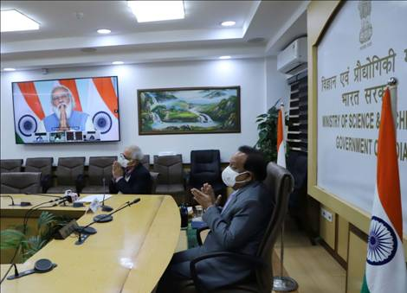

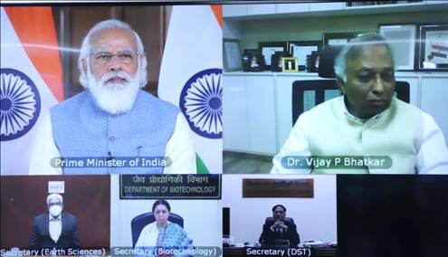
The sixth edition of this mega science festival will take place from December 22 -25, 2020 with the theme ‘Science for Self-Reliant India and Global Welfare’. It aims to celebrate the achievements of India's scientific and technological advancements with students and innovators.This virtual edition of the festival will also engage with the public, showing them how science, technology, engineering, and mathematics (STEM) play a pivotal role by providing solutions to improve our lives.
IISF 2020 is being organized jointly by Council of Scientific and Industrial Research (CSIR), Department of Science and Technology (DST), Ministry of Earth Sciences, Department of Biotechnology (DBT), Indian Council of Medical Research (ICMR) in association with VijnanaBharati. The nodal institution for science festival this year is CSIR-National Institute of Science, Technology and Development Studies (NISTADS), New Delhi.
Detailed information is available on IISF website-www.scienceindiafest.org
And PIB website: pib.gov.in/iisf

Text of PM’s inaugural address at India International Science Festival:

Source
Press Information Bureau, 22 December, 2020

