Women leaders deliberate on various policies and best practices to promote women in S&T
Eminent women leaders in science and technology underlined the need for a change in the mindset of people to end the of stereotyping of women and give them due respect and recognition at a panel discussion organized on the occasion of International Women’s Day.

Dr. Anita Gupta, Adviser & Head, National Science & Technology Entrepreneurship Development Board (NSTEDB), urged women to take charge of their life at the panel discussion organized by Department of Science and Technology (DST), Government of India, Centre for Policy Research Indian Institute of Science and UNESCO on “Mainstreaming Gender in STEM: Policies and Practices”.

She observed that the secondary results show good results from girls, but the leaking pipeline at the later stages is mainly because of the mindset and attitude towards women.

Talking about the unique perspective to science and research that women can bring, Director, British Council South India Janaka Pushpanathan pointed out that although employment in STEM is increasing, we need to take care of the issues that women face and provide girls more opportunity to engage with science and have role models for them.

Dr. Maan Singh Sidhu, Science, Technology and Higher Education Counsellor, Royal Norwegian Embassy in India, highlighted that women are the half population of the world, and they cannot be out of science technology ecosystem. “Leadership Development Programme, changes in curriculum to attract girls, policy for gender balance in research are some of the ways that could help increase the number of women in STEM, and we have implemented these programmes for improvement,” he said.

Speaking about the problems women face while breaking into the STI ecosystem, Dr Tonya Blowers, Programme Coordinator, Organization for Women in Science for the Developing World (OWSD), said that though efforts are being made at various levels, a lot still needs to be done to encourage women in the field of science, technology and innovation.

Dr. Mahaletchumy Arujanan, Global Coordinator, the International Services for the Acquisition of Agrobiotech Application (ISAAA); and Executive. Director, Malaysian Biotechnology Information Centre (MABIC) stressed that STEM has been male-dominated, and breaking the glass ceiling to enter boys group is not easy for women. She points out despite the increase in number of women scientists when asked to name a scientist, the image of male scientists emerge even in the minds of people from developed countries. “Women play an important role in this world, and they are 50 per cent of the world population, but they are still missing the gains. We need to make them a part of this world for a better life and future”, she said.
The speakers deliberated on various policies and best practices at regional, national and global levels as well as various challenges and opportunities in planning and implementation of such interventions, models, and frameworks for addressing gender inequities and biases in STEM and STI.

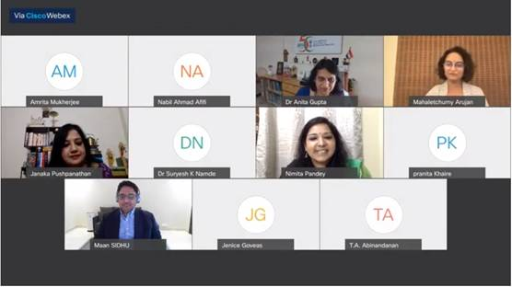

Source
Press Information Bureau, 09 March, 2021

