VigyanYatras to promote Scientific Temper among Masses being organised by various institutions ahead of IISF 2020

This science journey will be organized around 30 locations across the country
This Science Festival is going to impact and benefit every segment of society: Dr. Shekhar Mande, DG, CSIR
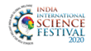

VigyanYatra is a promotional activity of the India International Science Festival. In this activity, the mobile science exhibition vansflag off from many cities of the country and the vision behind this science journey is to promote scientific temper and inculcate the culture of science among the masses. Thisprogram also ignites the minds of the youngsters because science exhibition mobile vansare viewedby all local school/university students that create interest in science and generate awareness about the IISF. This 6th edition of IISF is going to be organized on virtual platform due to the unprecedented Covid-19 pandemic. Around 30 locations have been identified across the country where this science journey will be organized. Eminentscience communicators, innovators, teachers, students and research scholars of the locality will be felicitated.
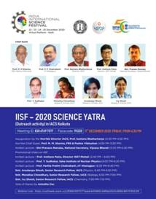

Indian Association of the Cultivation of Science (IACS), Kolkata organised this VigyanYatra virtually recently. Prof. Santanu Bhattacharya, Director, IACS inaugurated the programme. Chief Guest Prof. M.M. Sharma, FRS and Padma Vibhushan shed light on the importance of International Science Festival and the need and outcomes of this unique activity ‘VigyanYatra’. Invited lecture was delivered by Shri Praveen Ramdas, National Secretary, VijnanaBharati. Prof. AmitavaPatra, Director, INST (Mohali), Prof. Y. Sudhakar, Saha Institute of Nuclear Physics, Prof. ParthaPratimChakrabarti, IITKharagpur also gave lectures.

CSIR-Central Institute of Mining and Fuel Research (CIMFR), Dhanbad also organized ‘VigyanYatra’ on Youtube platform,under the East segment of four segments (East, West, North and South) cover the whole country.
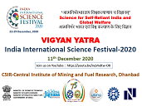
In a similar programme by CSIR-National Institute of Oceanography (NIO), Goa, Prof. Sunil Kumar Singh, Director, CSIR-NIO gave the welcome address. Director General, CSIR and Secretary, DSIR, Dr. Shekhar C. Mande in his presidential address, said that this science festival is going to impact and benefit every segment of society.

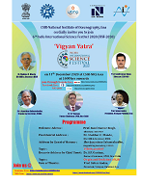

Guest of Honour Shri Jayant Sahasrabudhe, National Organising Secretary, VijnanaBharati (VIBHA) discussed the significance and major highlights of IISF 2020. He elaborated his lecture on the theme “VIBHA and IISF”.
Dr. S.P. Gautam, former Chairman, Central Pollution Control Board, New Delhi joined this program and shared his views on the theme of “Origin and Evolution of Life”. Prof. SuhasGodse, President, VidnyanParishad, Goa gave vote of thanks.
India International Science Festival 2020 organizes Curtain Raiser, VigyanYatra and Outreach programs as the pre event activities. Institute of Bioresources and Sustainable Development (IBSD), Imphal (Manipur), an autonomous Institute under the Department of Biotechnology, also held the Curtain Raiser Event cum VigyanYatrafor IISF-2020.

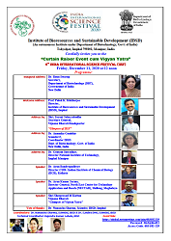
In this virtual program, Prof. Pulok K. Mukherjee, Director, Institute of Bioresources and Sustainable Development welcomed all the guests and dignitaries and gave a brief account of the India International Science Festival 2020.Inaugural address was given by Dr.RenuSwarup, Secretary, DBT. This mega science event on virtual environment is going to be organized during 22-25 December 2020 and CSIR is the Coordinating Organization and CSIR-NISTADS, New Delhi is the Nodal Institution for this event.

Shri.Jayant Sahasrabudhe, National Organising Secretary,VijnanaBharati discussed about the vision and objectives of this science festival and elaborated on the events which are to be conducted during IISF 2020.

Other speakers who delivered lectures were Dr. AnamikaGambhir, Scientist F, Coordinator IBSD, DBT, New Delhi;Dr. GoutamSutradhar, Director, National Institute of Technology, Imphal(Manipur);Dr. ArunBandyopadhyay, Director, CSIR-Indian Institute of Chemical Biology (IICB), Kolkata;Dr. Arun Kumar Sarma, Director General, North East Centre for Technology Application and Reach (NECTAR), Shillong (Meghalaya) and Shri Sheeprasad M.Kuttan, VijnanaBharati.

Source
Press Information Bureau, 14 December, 2020

