From Touchless Soap & Water Dispenser, Mechanical Ventilator to Pioneering E-classroom Software or Low-cost Rapid Diagnostic Device and Innovating Air Providing Virus Destroying Mask, Covid 19 has forced Scientists to Seek for Fastest Innovations to Survive, Opine Researchers
Miss Digantika Bose studies in Class XII at Memari V M Institution Unit II, Burdwan. But in her tender age she is very much influenced by the principle of Thomas Alva Edison that ‘To invent, you need a good imagination and a pile of junk’. And as the proverb goes, Necessity is the mother of invention, Digantika has felt the utter helpless- ness of common people in the wake of Covid 19 pandemic to survive and has come up with Air Providing and Virus Destroying Mask which has received the acclaim from Science and Technology Ministry, Government of India. Likewise, the IIT Kharagpur has deviced e-classroom low bandwidth software Deekshak for educational institutions, by which a teacher could concentrate on the screen with the teaching materials while being able to view queries on a live chat box where each student can send in their queries. Students also have access to a doubt box where they can click to “raise their hands” and wait for the teacher to address it, as is done in a physical classroom. Teachers can also share documents with the students through the platform and even update notes on the documents in real-time. All these were discussed today in a webinar organised jointly by the Press Information Bureau and Regional Outreach Bureau, Chuchura as a part of Prime Minister, Shri Narendra modi’s vision of Atmanirbhar Bharat. The panellists included Professor V K Tewari, Director, IIT kharagpur, Professor (Dr) Harish Hirani, Director, CSIR-CMERI, Durgapur, Shri V S Ramachandran, Director, Birla Industrial & Technological Museum, Dr Biswarup neogi, Associate Professor and Head, ECE Department, JIS College of Engineering, Kalyani and last but not the least, Miss Digantika Bose.

Professor Tewari also delineated the institution’s invention of a novel portable rapid diagnostic device to detect Covid-19 infection at an affordable cost for the marginal people of this country.

According to Professor Dr Hirani, CSIR-CMERI Durgapur has not only come up with low-cost but high efficiency three-layered facemask, but also road sanitising tractor, mechanical ventilator, soap, sanitizer and dispenser, hospital assistive robot, solar-based IntelliMAST, 360 degree car flusher and dry fogging shoe disinfector, but of late it has developed mechanised sewage cleaning system for mechanical scavenging instead of the manual one to maintain the optimum high standards as well as to help contain the contamination chain through waste water.
Shri Ramachandran presented their technological interventions and contributions relating to the online ticketing and entry system, alcohol-free and Ayurvedic entry tunnel, touchfree operation of exhibits, UV based product sanitizer, virtual tour and classes, image processing for crowd control, human motion-based sanitizer dispenser and the like.

Miss Bose, apart from face mask-cum virus destroyer, showcased her innovations like homemade transparent faceshields, distance arrester for police, ear pressure reduction tool due to the use of masks and many others.

Dr Neogi, made his presentation relating to dew of his innovations developed by his team to deal with the pandemic like Corona evading gloves capable of automatic sanitization with alcohol, currency and coin disinfector, raincoat turned PPE kit and his idea on waste to mask.

The Additional Director General (M & C), Ministry of Information and Broadcasting, Miss Jane Namchu was also present in the webinar. The webinar was moderated by Smt Srijata Saha Sahoo, Media & Communication Officer, Press Information Bureau, Kolkata and Shri Sandipan Dasgupta, Field Publicity Officer, Field Outreach Bureau, Chuchura.

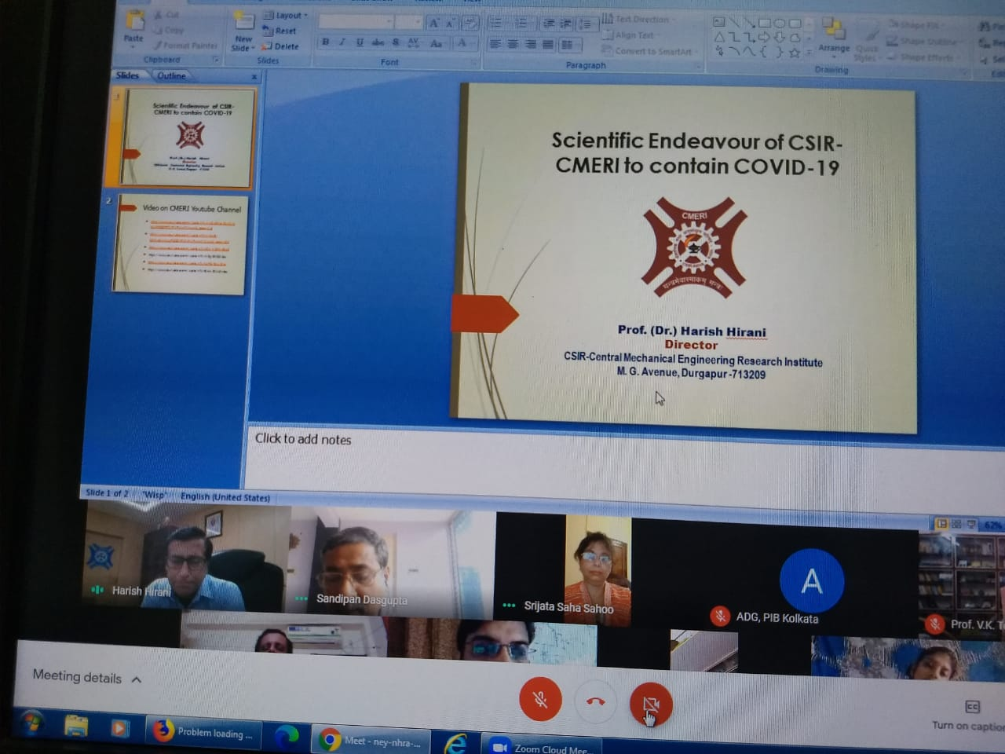
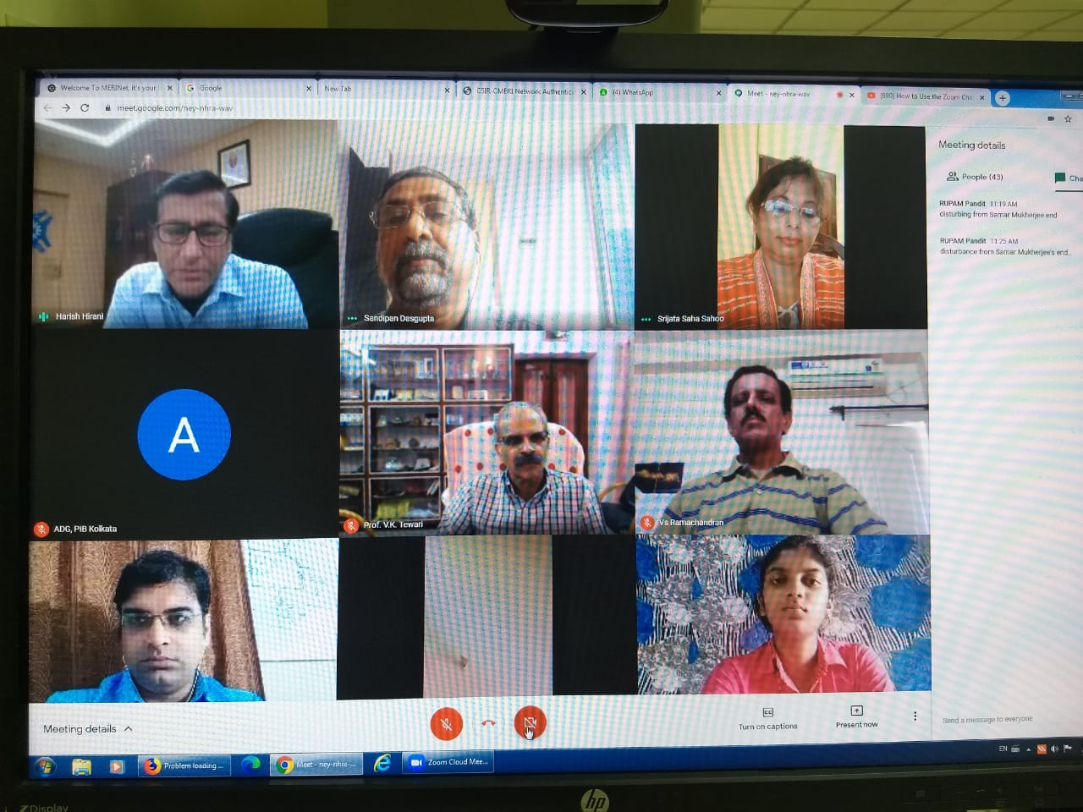

Source
Press Information Bureau, 13 September, 2020

