CSIR-CMERI unveils ‘Aqua Rejuvenation Plant’ which facilitates an Organic Farming Model through treated Waste Water
CSIR-Central Mechanical Engineering Research Institute, Durgapur unveiled the first-ever WasteWater Treatment Technology Model which purifies Waste Water for Irrigation/Farming purposes. Prof. (Dr.) Harish Hirani, Director, CSIR-CMERI inaugurated the ‘Aqua Rejuv’ along with Shri SubhenduBasu, Additional District Magistrate (Zila Parishad), Paschim Bardhaman and Additional Executive Officer, Paschim Bardhaman Zila Parishad today at CSIR-CMERI colony in Durgapur (West Bengal).
During his inaugural speech Prof. Hirani said that he wanted the solution for the society from Carbon Dioxide, frequent chockage of the drainage system and the discharge of sewage water through application of basic sciences. He also referred to different studies where it has been outlined that the COVID virus have the potential to survive up to 34 days in the sewage water. Keeping in mind these societal aspects, he envisioned this technology following the norms of the National Green Tribunal which is the statutory body for handling the expeditious disposal of the cases pertaining to environmental issues in our country.

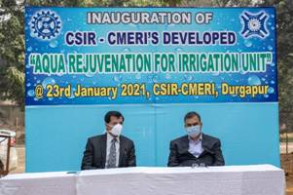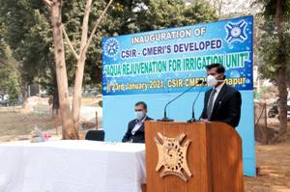

Aqua Rejuvenation Plant (ARP) is an Integrated Waste Water Rejuvenation Model which has Six-Stage purification profile for comprehensive treatment of Waste Water, based upon diverse purification parameters. The approx. 24,000 litres of Water that can be rejuvenated using ARP will be sufficient for almost 4 acres of Agricultural Land (barring seasonal variations in water requirements). The used filtration media have been specially developed to handle Indian Sewage Water Parameters and based upon Geographical Variations they may be modified. The filter media is also locally source-able, so as to ensure that there would not be any stress in the Supply Chain for scaled-up Manufacturing of ARP. The treated water which is now being used for irrigationcan be used even for drinking purpose also when little more time is given for settling. The system has dual benefit as while the treated water is being used for irrigation purpose, the filtered sludge generated is also utilized as manure / fertilizer. The bio char prepared from dry leaves falling in autumn season is also used for mixing in soil as it reduces the water requirement for irrigation thus saving precious water. The Institute was earlier also using alternate technologies like sprinkle system and others for reduced water requirement for such purpose. Prof. Hirani urged the different stake holders of the Society, Civic bodies, Governmental authorities, NGOs to come forwardand work with the scientific community.
Shri SubhenduBasu appreciated the scientific efforts of the Institute and stated that this technology is a much needed one in the present environment. He said that shortly the Municipal Corporation, Irrigation Department and the District Administration would arrange a seminar with CSIR-CMERI to discuss the issue for its proper implementation at the required places. Shri Basuexpressedconfidence that CSIR-CMERI has the potential and R&D solutions to the Industrial pollution related issues including waste water management.

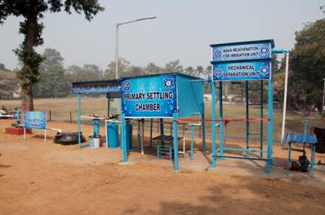

Source
Press Information Bureau, 23 January, 2021

