Technology Transfer of CSIR-CMERI Developed Water Purification Technologies
CSIR-CMERI transferred four indigenously developed Water Purification Technologies to three prominent MSMEs engaged in the Water Purification domain on 9th February 2021, in the presence of Prof. Harish Hirani, Director, CSIR-CMERI at a Press Conference. The MSME partners hailed the indigenously developed Water Purification technologies as a major stepping stone towards Self-Reliance and Import-Substitution.
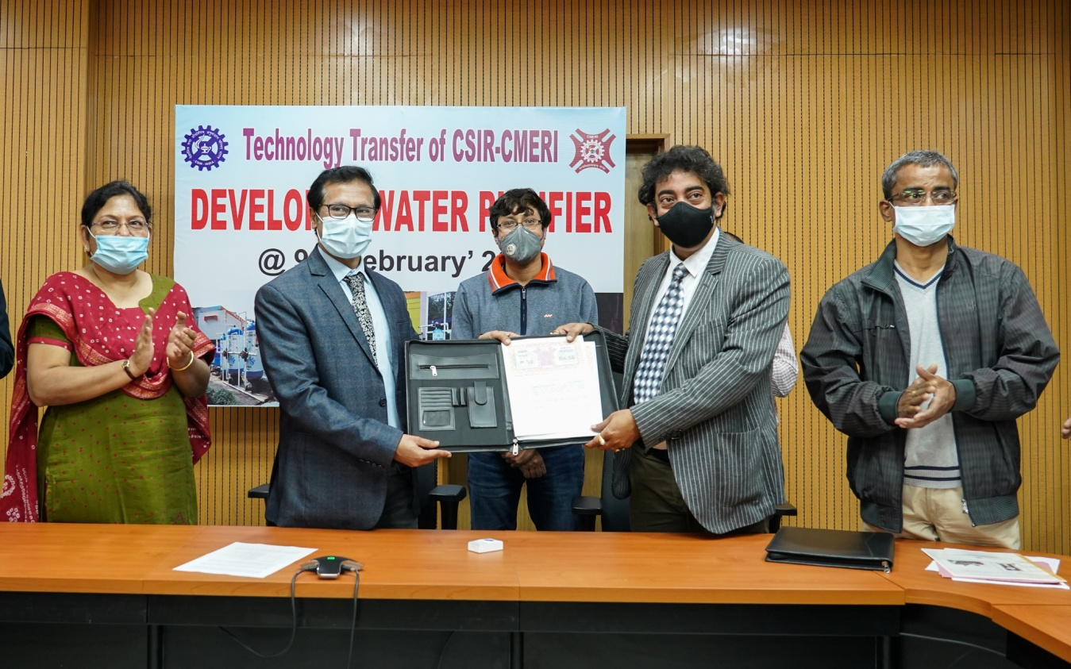
Prof. Harish Hirani on this occasion shared, “There is a huge scarcity of Water across the Globe and it is more so for Drinking Water. CSIR-CMERI is focussed upon Research & development of Affordable Water Purification Technologies, because penetration of these technologies to the rural regions of the country is utmost significance and it can be effectively achieved only when we forge a partnership with the MSMEs. The MSME partners can also tremendously benefit by availing the Government Marketing Promotion Schemes, to reach out to our immediate neighbouring countries and African Nations. Every region requires tailor-made purification solutions as per the variability of the local parameters and thus CSIR-CMERI developed technologies are designed in a modular fashion to increase its dynamicity and effectiveness for diverse geographical regions. The CSIR-CMERI Water Testing Facilities can facilitate the assessment of local Water Parameters and thereafter in partnership with the Local Government Institutions, this Institute can develop solutions for impactful Water Treatment.”In response to queries by the Media Personnel, Prof. Harish Hirani shared CSIR-CMERI ensures holistic Technology Follow-Up to the MSME partners for ensuring Market Outreach.
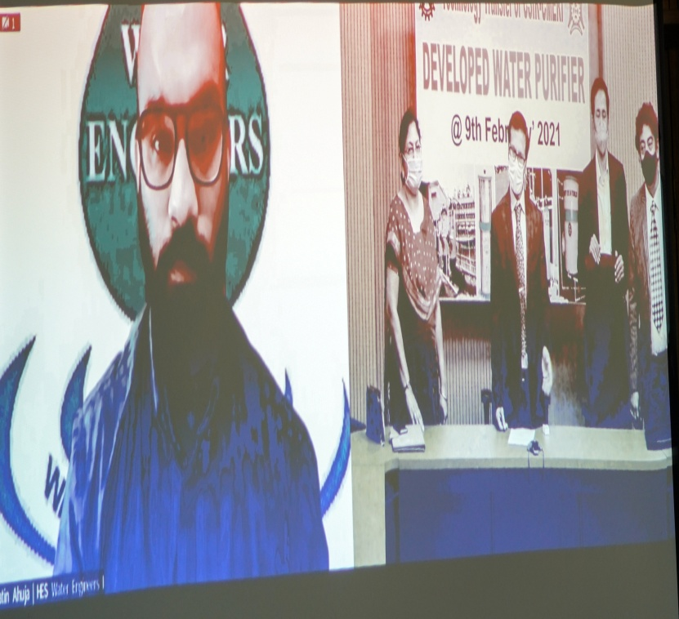
The technologies were transferred to the following MSME partners:

Sl.No. | Name of Technology | Name of Licensee
1 | High flow rate Arsenic removal filter | M/s TECHNOCHEM,KNC Road, Barasat,  North 24PGS- 700124, WB  Mr.Sumit Mukherjee  (M) 93396003256, Email: watersumit@gmail.com
2 | Domestic Iron Water Filter | M/s Zenith Aquatech, 292, SaratChatterjee Road, Shibpur, Howrah-711102, WB  Mr.SouravGanguly, (M) 9830043695
3 | Domestic Fluoride, Arsenic & Iron Removal (FAIR) filter | M/s Zenith Aquatech, 292, SaratChatterjee Road, Shibpur, Howrah-711102, WB  Mr.SouravGanguly, (M) 9830043695;  Email: mail.zenithaqua@gmail.com
4 | High flow rate Fluoride & Iron removal filter | M/s HES Water Engineers (India) Pvt.Ltd., K-27, 5Star Industrial Area, MIDC, Buttibori, Nagpur-441108, Maharashtra  Mr.JatinAhuja, (M) 9921208383  Email: jatinahuja@hesweindia.com

Shri Sourav Ganguly, M/s Zenith Aquatech, Howrah, shared, “The already transferred CSIR-CMERI Water Technologies has had tremendous Market Response. The CSIR-CMERI indigenously developed Water Purification Technologies are much more effective and affordable than imported technologies already being used by the Company. These technologies are reliable & authentic owing to the technical assurance of brand CMERI. The CMERI technologies are playing a crucial role in promoting the Jal Jeevan Mission of the Government of India and can be one of the most prominent factors in achieving water sufficiency for the nation.”

Shri Sumit Mukherjee, M/s TECHNOCHEM, Barasat, shared, “When compared with imported technologies , the CSIR-CMERI developed high flow rate arsenic removal technology is more affordable & sustainable . The Raw Materials are easily available and low maintenance. Numerous regional projects in Bihar have been successfully implemented using CSIR-CMERI Water Technologies. CSIR-CMERI developed water purification technologies are purely society-centric and the profit-motive of the MSMEs.

Mr.JatinAhuja of M/s HES Water Engineers(India) Pvt. Ltd shared, “After 16 years in the domain of large-scale Water Purification, we are hereby forging a partnership with CSIR-CMERI, owing to the Market Stature that it is steadily gaining in the domain of Water Purification. The Technology initiatives of CSIR-CMERI will help achieve Atma Nirbharta in the truest sense and us MSMEs are enthusiastic to partner in this progress.”

Source
Press Information Bureau, 09 February, 2021

