CSIR-Centre for Cellular and Molecular Biology (CCMB), Hyderabad is Engaged in the Fight Against COVID-19 on Multiple Fronts

CSIRs constituent leading biology lab CCMB based in Hyderabad is employing several tools and approaches in the countries fight against COVID-19.

Some of the key recent highlights are:

Testing patient samples
CCMB is an authorized testing centre for COVID-19 and receives patient samples from government hospitals across 33 districts of Telangana to check for SARS-CoV-2 virus. Currently, test capacity is around 350 samples a day.

Training on COVID-19 Testing
It has also trained 25 medical doctors, technical staff and students from five government hospitals - NIMS, IPM, Govt Fever Hospital in Hyderabad and Kakatiya Medical College, Warangal. These trained people have been deployed for the testing activities at their respective hospitals. Further, CSIR-CCMB has also created training videos on best practices for handling patient samples and on RT-PCR. These videos are available for authorized centers and can be got by contacting director@ccmb.res.in

Sequencing of the SARS-CoV-2 genome
CSIR labs are leading the way in genome sequencing of the Corona Virus and CCMB is performing Next Generation Sequencing and analysis to map out the whole genome sequence of the SARS-CoV-2 virus. The patient samples with CCMB that show high viral load are chosen for genome analyses. CCMB has sequenced a few patient viral isolates and aims to sequence several hundred virus isolates in next 3-4 weeks.

Culturing SARS-CoV-2 Virus for Testing Repurposed & New Drugs
A key tool lacking for the R&D community is the lack of viral cultures to test repurposed drugs, or new drugs or new molecules predicted by various molecular modelling. CSIR-CCMB has been engaged in this task and is setting up a system for culturing the SARS-CoV-2 virus in Vero cell line which are permissive for growth of viruses. It is hoped to be ready soon.

Lastly, CCMB has also been actively engaged in conveying various precautions and advisories on Corona Outbreak by innovative means in regional languages on social media platforms to the public at large.
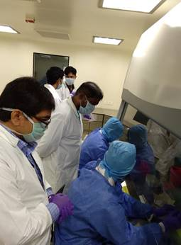  Testing of Corona Samples | 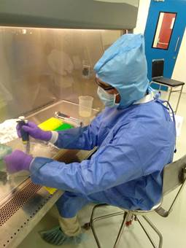  Training of Medical Staff on RT-PCR

Source
Press Information Bureau, 12 April 2020

