JNCASR kicks off crash course in molecular diagnosis of infectious diseases focusing on COVID 19

The course is designed to impart theoretical knowledge as well as hands-on training
Only simulated samples, not containing an infectious virus, have been used for training

Jawaharlal Nehru Centre for Advanced Scientific Research (JNCASR), an autonomous research institute under the Department of Science & Technology, Govt of India, has established a state-of-the-art COVID Diagnostic Training Centre at its Jakkur campus to help build capacity for the national fight against COVID 19 pandemic.

Molecular diagnostic techniques, such as the real-time PCR, play a crucial role in the diagnosis and tracking of epidemics, including COVID-19. Unfortunately, India lacks personnel skilled in and adept at performing a real-time PCR in clinical diagnostics. Appreciating the crucial and unmet needs of the nation, JNCASR has embarked upon a campaign by establishing a state-of-the-art diagnostic training facility to train personnel in a real-time PCR for COVID-19. The primary objective of the program is to train multiple batches of trainees, 6-10 trainees per batch, in real-time PCR.

The program envisages training people in multiple and sequential batches over the coming months through crash course spanning over a week. The first batch has undergone training from June 16 to 22, 2020, at COVID Training Facility, JNCASR.

The comprehensive crash-course spanning over a week comprisesboth classroom lectures and laboratory experiments. The course is designed to impart theoretical knowledge as well as hands-on training. The practical laboratory sessions have taught the participants the processing of infectious samples, nucleic acid extraction and preservation, real-time PCR and other molecular techniques, data analysis, and, importantly, standard operating protocols (SOP) of a clinical diagnostic facility. Only simulated samples, not containing an infectious virus, have been used for training. Following the course, the trainees will be well-positioned to join a clinical diagnostic facility and handle samples in a clinical setup and perform a real-time PCR for not only COVID but any infectious organism.

“Scientific robust training on handling and processing of infectious samples, use of real-time PCR and other molecular diagnostics, data analysis, and the standard operating protocols (SOP) of a clinical diagnostic facility are not only extraordinarily important in the time of COVID-19, but will continue to ensure the preparedness of the nation in the future to speedily address similar threats,” said Prof Ashutosh Sharma, Secretary, DST.

The program is open for young candidates with a graduate or post-graduate degree in medical laboratory testing (MLT degree) offered by any medical institute in India. Personnel currently engaged in clinical service, and diagnostic laboratories are especially encouraged to apply for the training. Registered personnel are offered a suitable remuneration in addition to free boarding and lodging by the institute.

Photographs from the training programme
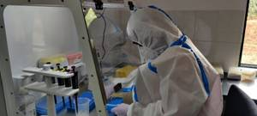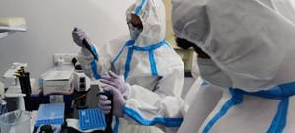

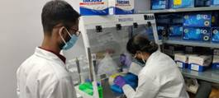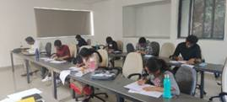

Source
Press Information Bureau, 24 June, 2020

