Technology Information, Forecasting and Assessment Council (TIFAC) celebrates its 34th Foundation Day

Cultural changes, connect of invention & innovation ecosystem can unlock self–reliance potential: Professor Ashutosh Sharma, Secretary, DST
Dr V.K. Saraswat, Member Science, Niti Ayog and Chairman-TIFAC identifies the technological priorities of the future like cyber-physical systems, quantum computing, green chemistry and water
Two new initiatives of TIFAC launched -- SAKSHAM-a dynamic job portal for mapping the skills of Shramiks vis-à-vis requirements of MSMEs and a Seaweed Mission for commercial farming of seaweeds
Two reports prepared by TIFAC -- ‘Techno-economic feasibility on Indian bamboo as Wood Substitute’ and ‘Opportunities for Fruit and Vegetable Processing in North Eastern region of India’ were also launched
Technology Information, Forecasting and Assessment Council (TIFAC), an autonomous organisation of Department of Science & Technology, today celebrated its 34th Foundation Day, here. The theme of the Foundation day was: “Technology, Innovation and Economy for Aatma Nirbhar Bharat”.
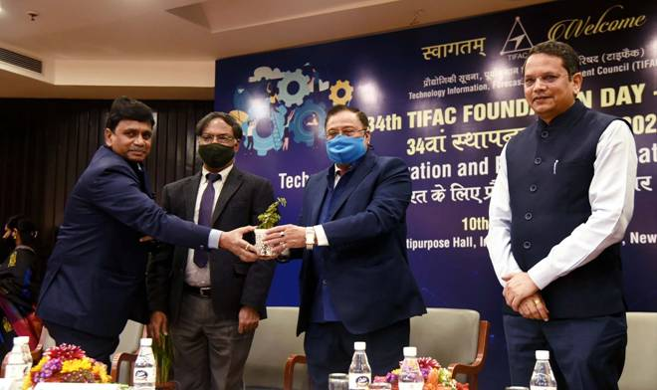

Dignitaries at the occasion highlighted that cultural changes, as well as connection of invention and innovation ecosystem, can unlock the potential for Atmanirbharata in India.
Secretary Department of Science and Technology (DST) Professor Ashutosh Sharma underlined how the Science Technology and Innovation Policy (STIP) and efforts by the TIFAC, could bring about cultural changes to connect the invention and innovation ecosystem and instill confidence to realise self-reliance in every sector through science and technology at the inaugural programme of the celebration.
“Our initiatives have already generated several start-ups. However, there can be a massive escalation in the numbers if we can trigger confidence in the youth to have their own start-ups. Atamanirbharata needs a change in mindset. The youth needs to think beyond themselves for the larger good of the society,” Professor Sharma pointed out at the celebration on February 10, 2021, focused on the theme ‘Technology, Innovation and Economy’ for AatmaNirbhar Bharat.
While underscoring the increasing nonlinearity of science in the new era, Dr V.K. Saraswat, Member Science, Niti Ayog and Chairman-TIFAC identified the technological priorities of the future like cyber-physical systems, quantum computing, green chemistry and water. He stressed that it is imperative to focus on technologies that can make India self-reliant or Atmanirbhar and are futuristic as well.
“We should identify those areas where technologies have made breakthrough and bring in indigenous technologies to be independent and globally competent. It is important to make sure we have an eye on the future as well as on the present, and that is where TIFAC’s role comes in a big way,” Dr Saraswat said.
He also added that the National Research Foundation (NRF) announced recently that it would create an ecosystem for providing a platform for futuristic research to bring our country at par with the rest of the world.
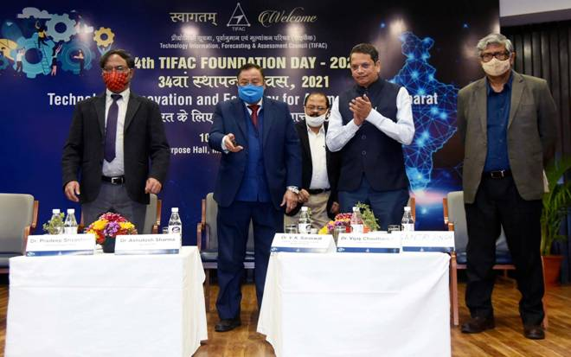

Two new initiatives of TIFAC—SAKSHAM (Shramik Shakti Manch)- a dynamic job portal for mapping the skills of Shramiks vis-à-vis requirements of MSMEs to directly connect Shramiks with MSMEs and facilitate placement of 10 lakh blue-collar jobs and a Seaweed Mission for commercial farming of seaweeds and its processing for value addition towards boosting national economy were launched on the occasion.
The SAKSHAM job portal will help eliminate middlemen/ labour contractor as well as help identification of skill proficiency level and development of Skill Cards for Shramiks.
Two reports prepared by TIFAC -- ‘Techno-economic feasibility on Indian bamboo as Wood Substitute’ and ‘Opportunities for Fruit and Vegetable Processing in North Eastern region of India’ were launched by Dr Vijay Chauthaiwale, an independent Healthcare consultant.
The celebrations also included a Tech Talk on the road ahead for rebooting, reinventing & resilience by Prof. K. Vijay Raghavan, Principal Scientific Adviser to the Government of India.
The celebrations were attended by Dr. Pradeep Srivastava, Executive Director TIFAC while several other dignitaries joined online .
A brief of all these initiatives are mentioned in this context.
- Seaweed Mission

By an estimate, if sea weed cultivation is done in ≈10 million hectares or 5% of the EEZ area of India, it can provide employment to ~ 50 million people; set up new seaweed industry; contribute to national GDP; ocean productivity; abate algal blooms, sequester millions of tons CO2; create a healthier ocean; produce bio-ethanol approx. 6.6 billion litres.
TIFAC will demonstrate a model along with other inline ministries for commercial farming of seaweeds and its processing for value addition towards boosting national economy.

- SAKSHAM
The COVID-19 pandemic compelled the labour force to return to their native lands due to loss of jobs. TIFAC has developed SAKSHAM, a dynamic job portal for mapping the skills of Shramiks vis-à-vis requirements of MSMEs across the country.
This initiative will facilitate placement of 10 lakh blue-collar jobs (pan-India), directly connect Shramiks with MSMEs eliminating middlemen/ labour contractor, identification of skill proficiency level and development of Skill Cards for Shramiks. This portal will reduce the hardship of Shramiks in finding jobs in nearby MSMEs.
On the occasion of the Foundation Day function, TIFAC Employees completing 25 years of service were felicitated by Dr V K Saraswat.

Source
Press Information Bureau, 10 February, 2021

