IIT, BHU to re-purpose approved drugs from DrugBank database for treating COVID-19 by targeting SARS-CoV-2 main protease

The Science and Engineering Research Board has approved support for research at IIT (BHU) Varanasi to identify lead compound(s) from available and approved drugs for fast-track anti-SARS-CoV-2 drug molecule.

Scientists and healthcare professionals over the world are trying for a cure for the pandemic, which afflicts the world today. At present, available treatments are focused only on symptomatic relief to help the patient overcome the infection. Repurposing of pre-existing drugs could help circumvent both the time and money required to find an effective cure.

The research group of Prof. Vikash Kumar Dubey is working on developing new drug candidates against SARS-CoV-2 by exploring DrugBank (DrugBank is a database of FDA approved drug compounds. This database will be used for searching drug against SARS-CoV-2) database compounds as an inhibitor of SARS-CoV-2 main protease, a key enzyme required for SARS-CoV-2 assembly and multiplication. They will be carrying out extensive computational and experimental studies to identify an inhibitor of SARS-CoV-2 main protease.

Taking advantage of available crystal structure of the SARS-CoV-2 main protease, a structure-based inhibitor design will be done by the researchers from the available FDA approved drugs compounds in the DrugBank database.

Subsequently, experimental validation of the designed inhibitor(s) on recombinant SARS-CoV-2 Mpro Protein will be carried out. Various inhibitor parameters will be calculated to establish the effectiveness of the inhibition of the SARS-CoV-2 Mpro enzyme function. As the enzyme SARS-CoV-2 Mpro, is key for processing and polyprotein for virus assembly, the inhibition of this key protein can have an anti-viral effect. As most of DrugBank database compounds are characterized in terms of pharmacokinetics and toxicity, the identified molecule could be brought to the market rapidly.

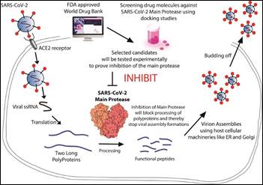

(For more details, please contact: Dr. Vikash Kumar Dubey, vkdubey.bce@iitbhu.ac.in)

Source
Press Information Bureau, 02 June, 2020

