Canister bag that solidifies infectious secretions like COVID 19can save health workers from exposure during handling
Infectious secretions from contagious diseases such as COVID 19, tuberculosis (TB), and influenza poses high risk for healthcare workers. Their exposure to the high-risk hazard while handling the waste can soon be controlled with a canister bag that solidifies the secretions rapidly, making disposal safer.

For the safe management of infected respiratory secretions, the researchers at Sree Chitra Tirunal Institute for Medical Sciences and Technology (SCTIMST), an autonomous institute under the Department of Science and Technology, Govt of India, have come up with a method for safe handling and disposal of respiratory secretions in hospitals for ICU patients or those with copious respiratory secretions treated in the wards. They have developed canister bags lined with super-absorbent material containing an effective disinfectant, named “AcryloSorb”.
When the patient is admitted to the hospital, secretions are sucked into bottles or canisters using vacuum line and discarded through the waste fluid disposal system after subjecting to decontamination process. There is a high risk of contamination during the handling, and the disposal needs well-equipped sluice rooms with disinfection facilities. The safety threat and manpower issues will be manifold in less equipped hospitals or temporary isolation wards set up during pandemics.
The canister bags can absorb 500 ml of secretions and solidify it immediately. In addition to that, the whole system will be decontaminated within no time because of the presence of disinfectant. The liner structure has a patented design which allows the progressive absorbent availability upwards. Solidification and immediate disinfection that occurs inside these bags eliminate risk of secondary infections by avoiding spilling and aerosol formation, and thereby protect healthcare workers and promote safe workplace management.Canister bags are enclosed in a customizable sealer bag which can pack it as spill-proof decontaminated biomedical waste disposable through incineration. The product has been tested as per the international standards.
The SCTIMST team that realized this technology consists of biomaterial scientists and clinicians - Dr. Manju, S., Dr. ManojKomath, Dr. Asha Kishore, Dr. Ajay Prasad Hrishi. The know-how of the AcryloSorb suction canister liner (CL Series) bags has been transferred to Romsons Scientific and Surgical Pvt. Ltd for manufacture and immediate marketing. The approximate cost will be Rs. 100/- for each canister liner bag.
Romsons Scientific & Surgical Pvt. Ltd, located at Uttar Pradesh, is a global player in medical devices with more than 200 products in market. The company has proven expertise of half a century in the area of disposable medical and surgical devices and is a prominent brand in the medical device community. The company has its distribution channel across 65 countries. Quality is a prime motto of Romsons, evidenced by the ISO and CE certifications for many of their products.
The field trials of the in-house designed suction canister liner bags are being conducted in SCTIMST.

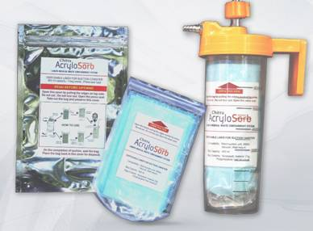

For further details, contact Dr.ManojKomath (manoj@sctimst.ac.in).

Source
Press Information Bureau, 4 September, 2020

