CSIR-CMERI Transfers technology of Community level Water Purification system by High Flow Rate Fluoride & Iron Removal

Strategic deployment of this Community Level system can help to turn the tide against menace of Iron and Fluorosis across the Nation

The CSIR-CMERI today transferred its High Flow Rate Fluoride & Iron Removal technology to M/s Capricans Aqua Private Limited, Howrah, West Bengal, in Durgapur (WB). The Technology Transfer took place over a Virtual Platform in the presence of Prof. (Dr.) Harish Hirani, Director, CSIR-CMERI, Durgapur.

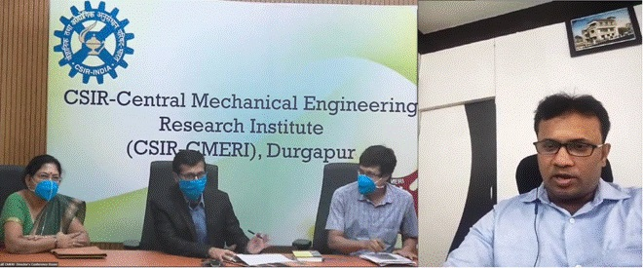
Prof.Hirani, during the event stated, “This Community Level Water Purification System has a Flow-Rate capacity of 10,000 Ltr/hr and uses commonly available raw materials such as sand, gravel and adsorbent materials. It comprises a three-stage purification process which purifies water within permissible limits (1.5 ppm & 0.3 ppm for Fluoride and Iron respectively). The technology uses a combination of Oxidation, Gravitational Settling and Chemisorption process in an Affordable Package. The integrated backwashing profile of the technology will help in improving the shelf-life of the filtration media in a resource rationalised manner”

Prof.Hiranisaid that, “As per available statistics the number of Fluoride affected individuals are continuously increasing in a contaminated habitat in the last 50 years. This has been happening in consonance with the disproportional depletion of Water Table, which has led to multiplication of the level of concentration of Fluoride in the particular region. Owing to inaccessibility to Affordable Fluoride Removal Solutions for the drastically affected sections of the Country, the Fluorosis affected statistics has also witnessed an upward trajectory. Besides, the technology is also a major thrust towards the AtmaNirbhar Bharat campaign. Proliferation of this technology will also help in catalysing Employment Generation opportunities for the Youth of the Nation. The strategic deployment of this Community Level system at affected places can help to turn the tide against the menace of Iron and Fluorosis across the Nation.”

Shri Sanjay Dutta, Director, Capricans Aqua Private Limited, said that CSIR-CMERI Water Technologies have provided an Affordable and Cost-Effective solution for serving the most vulnerable sections of the Nation. He said, the results generated after deployment of this Water Technologies will be immense. Capricans now intends to deploy the CMERI Water technologies in the Fluoride and Iron affected regions of the states of Jharkhand, Uttar Pradesh and Assam, he added.

Source
Press Information Bureau, 08 October, 2020

