CSIR-National Aerospace Laboratories (NAL), Bengaluru develop BiPAP Non Invasive Ventilator “SwasthVayu” in 36 Days for COVID -19.

The system has been certified for safety and performance by NABL accredited agencies and undergone stringent biomedical tests

CSIR - National Aerospace Laboratories (NAL) Bangalore, a constituent of lab of CSIR has developed a Non Invasive BiPAP Ventilator in a record time of 36 days to treat COVID-19 patients.BiPAP Non-Invasive ventilator is a microcontroller-based precise closed-loop adaptive control system with a built-in biocompatible “3D printed manifold & coupler” with HEPA filter (Highly Efficient Particulate Air Filter). These unique features help to alleviate the fear of the virus spread. It has features like Spontaneous, CPAP, Timed, AUTO BIPAP modes with provision to connect Oxygen concentrator or Enrichment unit externally. The system has been certified for safety and performance by NABL accredited agencies. The system has undergone stringent biomedical tests and beta clinical trials at NAL Health Centre.

The major advantage of this machine is that it is simple to use without any specialized nursing, cost effective, compact and configured with majority of indigenous components. This is ideal for treating COVID -19 patients in Wards, Make shift Hospitals, dispensaries and home in current Indian COVID 19 scenario.CSIR-NAL is in process of taking it forward with the regulatory authorities for the approval and expected to get shortly. CSIR-NAL has already initiated dialogue with major public/private industries as a partner for mass production.

DG CSIR, Dr Shekhar C Mande, complemented CSIR NAL team which has enabled a spin-off technology based on its expertise in the aerospace design domain. He also recalled the contribution of CSIR-NAL in the flight of indigenously developed Hansa-3, on May 11th in 1998, which is one of the achievements that is also celebrated on National Technology Day.

Director CSIR-NAL, Shri Jitendra J. Jadhav stated that based on global experience and specific inputs from pulmonologists in India and abroad, CSIR-NAL developed BIPAP Non Invasive Ventilator with externally connected Oxygen concentrator which will be ideal to treat moderate or mid-stage severe COVID-19 patients who do not require intubation and invasive ventilation.

The success is the culmination of efforts of team of technocrats and medical practitioners under the leadership of Dr. CM Ananda, Head Electronics Dept., Dr.Amarnarayan D, Chief Medical Officer- NAL, Dr. Viren Sardana – Respiratory Physiologist CSIR-IGIB and team of scientists at NAL who have worked relentlessly during Covid-19 restrictions.
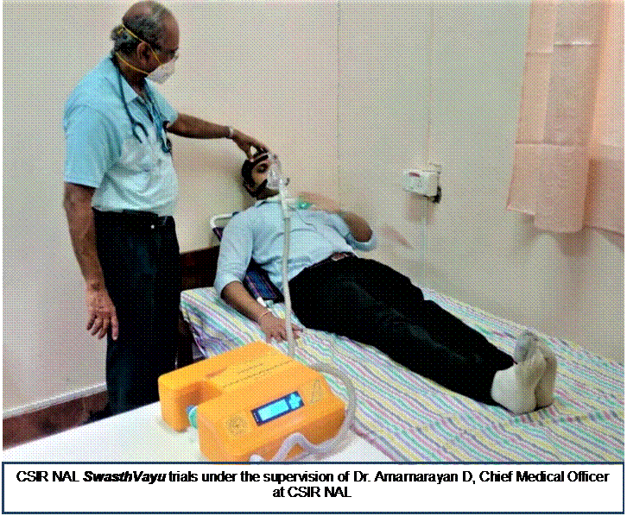

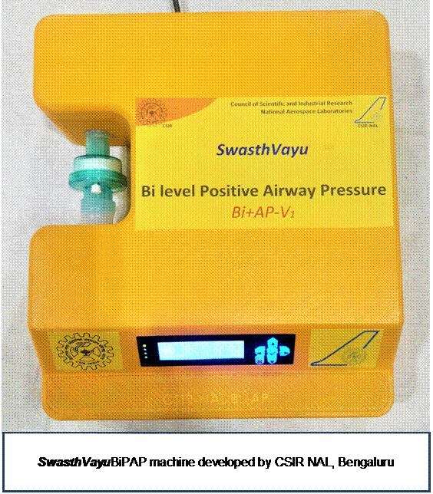

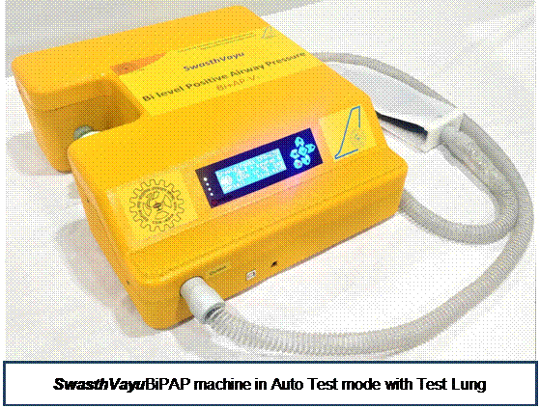

Source
Press Information Bureau, 11 May, 2020

