Dr. Harsh Vardhan chairs a meeting on COVID Appropriate Behaviour with Heads/Directors of Autonomous Institutions of DST and CSIR

“Next Two and Half months are going to be crucial in our fight against Corona because of the oncoming festival season and winters. Till the time a vaccine is available, follow the Social Vaccine”: Dr. Harsh Vardhan

Union Minister of Science & Technology, Earth Sciences and Health & Family Welfare, Dr. Harsh Vardhan today chaired a meeting with Heads/ Directors of Autonomous Institutions under the Department of Science &Technology (DST) and CSIR through video conferencing to review the activities taken under the “Jan Andolan” on COVID Appropriate Behaviour, here.

Highlighting the importance of the coming months in the country’s collective fight against the pandemic, Dr Harsh Vardhan said, “We are now entering into the tenth month of our fight against COVID-19. It was on the 8th of January when we had our first meeting of the expert group. Since then, the journey has been relentless. But today, we can proudly say that we have created significant infrastructure for our fight against COVID.” He expressed deep gratitude and salutations for the tireless and dedicated efforts by all COVID warriors and expressed grief over the death of those warriors who sacrificed their life saving others.

The Minister applauded the great work carried out by all scientists, even beyond their mandates, and said that today there are 9 vaccine candidates in the world which are in advanced stages. He said, in India, 3 vaccine candidates are developing well with one of them in the advanced Stage-III Clinical trials and two others in stage-II trials. He expressed the hope that India will soon have indigenousproduction of Corona vaccine.

Pointing out that the fight against COVID is not over yet, Dr. Harsh Vardhan cautioned people against complacence, carelessness and casual attitude towards combating COVID-19. He stated that “The next two and half months are going to be very crucial for us in our fight against corona because of the winter season and the festival season. It becomes responsibility of every citizen to not let our guard down and follow COVID appropriate behaviour to curb spread of the infection.”

Urging people across the country to follow the clarion call of the Prime Minister as part of the ‘Jan Andolan’ launched on the 8th of this month, the Minister appealed people to follow COVID appropriate behaviour. He said, “The virus has adversely affected the whole world. But simple precautionary measures are effective in preventing the coronavirus to a large extent. Wearing mask/face cover especially in public spaces, and following hand and respiratory etiquettes are the cardinal principles of social vaccine.” He stressed on the importance of physical distancing for effective containment of the disease. Dr. Harsh Vardhan asked all the heads of institutions to be the frontrunners in showcasing the importance of this Social Vaccine to break the chain of transmission of the disease in the country.

On India’s fight against COVID-19, Dr. Harsh Vardhan said, “India is continuously recording new milestones in treatment of Covid. Our Recovery rate is the highest in the world and the fatality is among the lowest. The Active Cases are constantly declining. All the parameters have proven the success of the COVID-19 containment strategy followed by all States and UTs. We have successfully ramped up our testing capacity to meet the requirements. India also has now become self reliant in terms of masks, PPE kits and ventilators which we earlier used to import.”

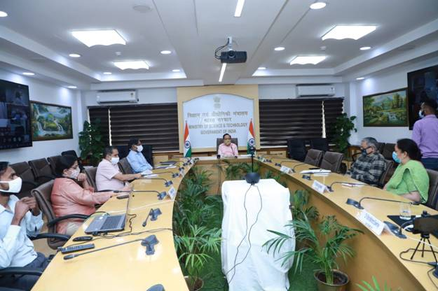

Source
Press Information Bureau, 16 October, 2020

