The National Council for Science & Technology Communications invites nominations for National Awards for Science & Technology Communication for 2020
Nominations have been invited for awarding outstanding contributions in the field of science and technology communication and for promoting scientific temper.

The National Council for Science & Technology Communications (NCSTC) Division of Department of Science & Technology (DST), Ministry of Science & Technology Government of India, has invited nominations for National Awards 2020 for Science & Technology Communication to recognize outstanding work in communication of science and technology. The awards shall be presented at New Delhi at a special ceremony on the 28th February, on National Science Day, every year.

The awards carrying a citation, a memento, and cash award is presented every year to an individual or an institution for outstanding contribution in the field of science and technology communication and for promoting scientific temper, which has created significant impact in the country during the last five years in 6 categories:

The categories are outstanding efforts in science & technology communication, which carries a cash award to of Rupees five lakh, science & technology communication through print media including books and magazines, science & technology popularization among children, translation of popular science & technology literature, science & technology communication through innovative and traditional methods, science & technology communication in electronic medium with the last 5 categories having a cash amount of Rupees 2 lakhs each.

The awards are conferred annually and are open to all Indian citizens above 35 years of age as well as to institutions registered in India or created by the Central/ State governments/ Union Territories recommended in writing by a competent authority.

For full details of the scheme, including eligibility conditions, application format, etc. interested applicants can go through the website of the Department: www.dst.gov.in.

Duly completed nomination form along with supporting documents should be sent to Dr. ABP Mishra, Scientist NCSTC Division, Department of Science & Technology, E-mail: apmishra@nic.in latest by 31 October 2020.

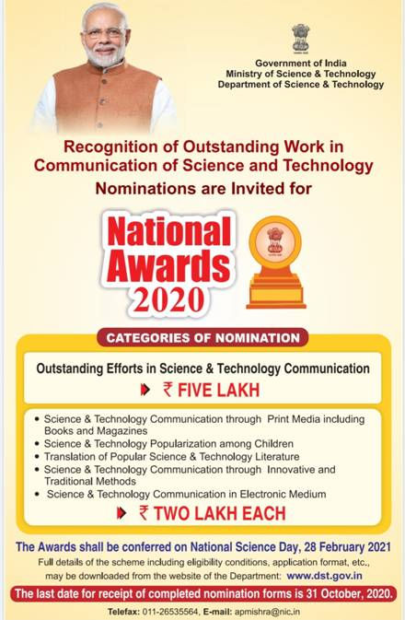

Source
Press Information Bureau, 06 October, 2020

