JNCASR Professor elected as International Honorary Member to the American Academy of Arts and Sciences

Professor Shobhana Narasimhan from the Theoretical Sciences Unit (TSU) at the Jawaharlal Nehru Centre for Advanced Scientific Research (JNCASR), an autonomous institute under the Department of Science & Technology, has been elected as an International Honorary Member to the American Academy of Arts and Sciences.
The American Academy of Arts and Sciences honours scholars and leaders who have distinguished themselves in the sciences, arts, humanities and public life. The list of previous International Honorary Members includes Charles Darwin, Albert Einstein and Nelson Mandela.

Prof Narasimhan heads the Computational Nanoscience group at JNCASR. She has done significant work on the rational design of nanomaterials, examining how the lowering of dimensionality and reduction of size affect material properties. Her work is relevant for a number of different applications, such as nanocatalysts for clean energy applications, and magnetic materials for memory storage.

Her group predicted that the morphology and reactivity of gold nanoparticles deposited on oxide substrates can be tuned by doping the support with electron donors or acceptors.

Prof. Narasimhan has also been very active in the promotion of women in STEM in India and abroad. She was a member of the Working Group for Women in Physics of IUPAP. Since 2013, she has been co-organizing Career Development Workshops for Women in Physics at the Abdus Salam International Centre for Theoretical Physics (ICTP) in Trieste, Italy, and the ICTP-EAIFR in Kigali, Rwanda.

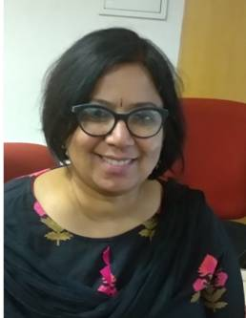

Awards and Recognitions
She became a Fellow of the National Academy of Sciences, India in 2011 and also received the Stree Shakti Samman Science Award in 2010 and the Kalpana Chawla Woman Scientist Award of the Government of Karnataka in 2010.
Prof. Narasimhan was a member of two committees set up by Govt. of India - the National Task Force on Women in Science, and the Standing Committee on Women in Science, to advise the government on how it can promote the cause of women scientists.
She has been involved with the Quantum ESPRESSO group as well as ASESMA (the African School for Electronic Structure Methods and Applications) in teaching solid-state physics and Density Functional Theory in workshops in Asia and Africa. She is a member of the Executive Committee of ASESMA, and also a member of the Scientific Council of the ICTP-EAIFR (East African Institute of Fundamental Research) in Kigali, Rwanda.
Before joining JNCASR in 1996, Prof. Narasimhan completed her Master's at the Indian Institute of Technology (IIT) Bombay, in physics, and a PhD in physics at Harvard University under the supervision of Prof. David Vanderbilt. She worked as a postdoc at Brookhaven National Lab in New York, USA and then at the Fritz Haber Institute of the Max Planck Society in Berlin, Germany. She was also formerly the chair of the Theoretical Sciences Unit, as well as the Dean of Academic Affairs at JNCASR.

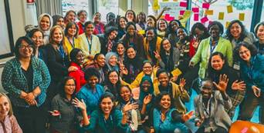
Prof Shobhana Narasimhan (2nd from L) at a workshop for women in physics organized by her at the International Centre for Theoretical Physics (ICTP).

[For more details contact Prof. Shobhana Narasimhan (shobhana@jncasr.ac.in, 98806 41962)]

Source
Press Information Bureau, 1 May, 2020

