NBRI establishes advanced virology lab for COVID-19 testing
The National Botanical Research Institute (NBRI), Lucknow, has established an “Advanced Virology Lab” for testing COVID-19. The facility has been developed based on the guidelines of the Indian Council Medical Research (ICMR), the World Health Organisation (WHO), and the Ministry of Health and Family Welfare.

It is a Bio Safety Level (BSL) 3 level facility. “Biosafety levels are assigned to a facility depending on the pathogen it deals with. According to ICMR guidelines, BSL2 level facility is recommended for COVID-19 but this is an advanced version,” said Dr Samir Sawant, Senior Principal Scientist, NBRI. This advanced version has a “Negative Pressure”, which means it has a suction facility that can suck any aerosol and pass it through filters. It can filter virus or bacteria to make it a safe COVID-19 testing facility. It reduces the possibilities of infections at culturing facilities.

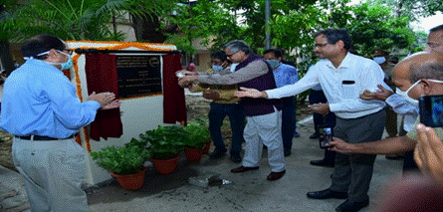
Inauguration of Advanced Virology Lab

Prof. S K Barik, Director, NBRI, said that the facility will add to the testing capacity of Uttar Pradesh (UP). At present, UP is testing about 20,000 samples per day.

“To follow the protocol, we will start testing 100 samples a day in the first week and later we will scale it up to 500 samples a day,” said Dr Sawant.

“As requested by the higher authorities of the Government of Uttar Pradesh and the Director General of the Council of Scientific and Industrial Research (DG-CSIR), NBRI took up the initiative for developing the testing facility in the wake of coronavirus pandemic as a service to the people of Uttar Pradesh,” Prof Barik said. Prof. Barik also informed that a team of scientists and researchers from the Central Institute of Medicinal and Aromatic Plants (CIMAP), Lucknow, will also join the NBRI team for the testing of COVID samples.

Source
Press Information Bureau, 30 June, 2020

