PSA Professor K Vijay Raghavan calls for unlocking entrepreneurship in design and training youth in machine learning
Principal Scientific Adviser to the Government of India Professor K Vijay Raghavan under scored the need for breaking open entrepreneurship in design across sectors to scale up technologies and boost local manufacturing for sustainable, inclusive development at his tech talk on ‘Reboot, Reinvent & Resilience – Road ahead’ organised on the occasion of the celebration of the 34th TIFAC Foundation Day.

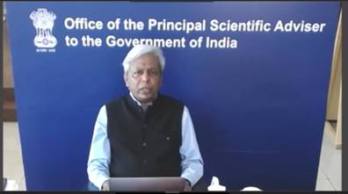

“For scaling up exponentially in focused areas, manufacturing should be distributed with design at the core of it. Prototyping and manufacturing of products can be done locally by entrepreneurs. Design companies anchors and links to Indian academia should flourish so that they have the confidence to make products of any kind anywhere in the world. We should move to a stage where we can make the products, design them and export the design competing globally,” Professor Vijya Raghavan stressed.

He also said that for distribution of knowledge as the basis of power, mathematics, statistics, and computer science learning should be brought to scale and machine learning based decisions which are consequence of those kinds of learning taken to our population in general. Research needs to be amplified to places like schools, colleges, and universities where 90% of our students go. “National Research Foundation (NRF) announced in some details in the budget this time could help training in research in general and science and technology in particular reach number of people,” Prof.VijayRaghavan added.

He called for the partnership of the entire scientific community in the road ahead for rebooting, reinventing & resilience to strengthen the innovation and research ecosystem of the country.
TIFAC is an autonomous organisation under DST which carries out technology foresight exercise, facilitates and supports technology development, prepares technology linked business opportunity reports and implements mission-mode programmes.

Source
Press Information Bureau, 12 February, 2021

