Dr Harsh Vardhan inaugurates the three-day Global Bio India 2021

Smt Nirmala Sitharam addresses the inaugural session as special guest
Dr Harsh Vardhan affirms that S & T ecosystem in India has always been a dynamic and evolving area, with the support of the Government through its different schemes and policies
“Over 6,000 delegates from over 50 countries will participate and around 24 knowledge sessions across different segments will be held over these 3 days”: Dr. Renu Swarup, Secretary DBT
The Union Minister for Science & Technology, Earth Sciences and Health & Family Welfare Dr. Harsh Vardhan today inaugurated the second edition of Global Bio-India-2021 in New Delhi through virtual mode. The 3-day event will showcase the strength and opportunities of the India’s biotechnology sector at national level and to the global community. The three day event being held from 1st to 3rd March 2021 has been organized on a digital platform. The theme for this year is “Transforming lives” with the tag line “Biosciences to Bio-economy”.

Being one of the largest biotechnology stakeholder conglomerates, this event is being co-organised by the Department of Biotechnology, Ministry of Science & Technology, Government of India along with its Public Sector Undertaking, and Biotechnology Industry Research Assistance Council (BIRAC) in partnership with industry association Confederation of Indian Industry (CII), Association of Biotechnology Led Enterprises (ABLE) and Invest India.

The Biotechnology sector has emerged as an integral part of the Indian economy over the past few decades, and the Government of India is playing a transformative and catalytic role in building a USD 150 billion bio-economy by 2025. The sector is recognized as one of the key drivers for India to achieve its USD 5 trillion target.

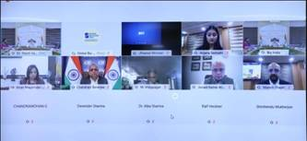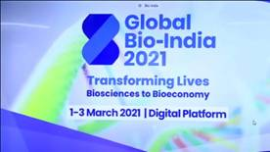

Dr. Harsh Vardhan, in his inaugural address, informed that science and technology ecosystem in India has always been a dynamic and evolving area, with the support of the Government of India through its different schemes and policies. “However, in the last year, with the background of the Covid-19 pandemic, its true power, resilience and capability have been unleashed with concerted efforts of the government and private sector together”, the Minister asserted. “The Government through Department of Biotechnology (DBT), its Autonomous Institutes and Public Sector Undertakings, Department of Health Research (DHR), DST, ICMR, CSIR have been working relentlessly to mitigate the COVID-19 global health crisis through development of diagnostics, vaccines, monoclonals, novel protection equipment, support to Start ups, scaling up of diagnostic capacity and rapid regulatory response. A multi-pronged research strategy and action plan was evolved for immediate response including augmentation of COVID -19 testing across the country as well as for long-term preparedness to tackle the COVID-19 infection”, he pointed out. By virtue of being close to life sciences, Biotech is the closest to human welfare, Dr Harsh Vardhan opined.

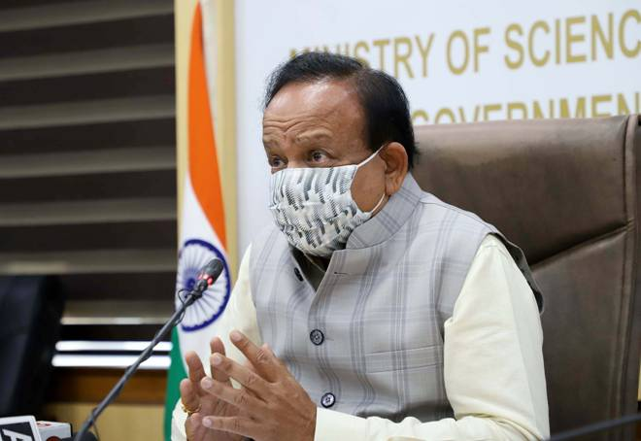

Dr. Harsh Vardhan also commended “ DBT - BIRAC for supporting technology -driven 3500+ Entrepreneurs, Startups and SMEs; through various operational models of cooperation and also building up a network of 55 Bio-incubators with more than 5,50,000+ sq.ft of incubation space”. “These initiatives have helped innovators to create a pool of intellectual wealth (260+ IP filed) and has supported the launch of 200+ products and technologies in the market”, he said.
Smt. Nirmala Sitharaman, Union Minister of Finance & Corporate Affairs, joined online as a Special Guest on the occasion. The Finance Minister lauded DBT for its tireless efforts for nurturing Biotechnology which, she said, “Is evident from the Bio-economy growing to the scale of 70 Billion USD”. Smt. Sitharaman also lauded the efforts of the Biotech sector for its role in the mitigation of Covid-19 pandemic by delivering COVID-19 diagnostics, vaccines and other solutions in an unprecedented time line. “This response is the way to go towards AtmaNibharta being advocated by the Prime Minister”, she said. The Finance Minister also highlighted the Budgetary support to R&D and Innovation ecosystem in the country in line with the “Atmanirbhar” vision.

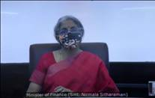

Dr. Renu Swarup, Secretary DBT in her welcome address, highlighted the vision of ‘Bio-Science life to Bio-science Economy’. She thanked Dr. Harsh Vardhan and Smt. Nirmala Sitharaman for their support and leadership for the biotechnology sector. Dr. Swarup informed that the second edition has over 6,000 delegates from over 50 countries and will be hosting around 24 knowledge sessions across different segments that will be held over these 3 days. Sessions will include - India Fights COVID: The COVID 19 Vaccine Journey from Science to Delivery; Health Conclave; Start-up Conclave; Phytopharma & Traditional Knowledge; Clean Energy Conclave; Precision Medicine & Data-Driven life Sciences; Women Entrepreneurs Conclave; State sessions; International Investor’s meet and many more, she informed.

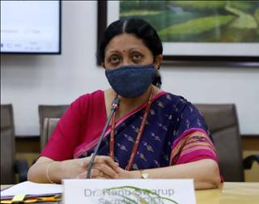

Dr. Harsh Vardhan unveiled the “National Biotech Strategy” and also inaugurated the Virtual Exhibition of Global Bio-India.

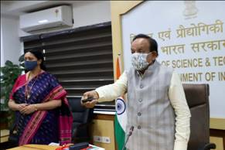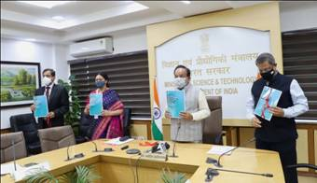

The inaugural session was attended by Dr. Ralf Heckner , Ambassador, Embassy of Switzerland in India and Bhutan; Mr. Marten van den Berg, Ambassador, Embassy of Netherlands in India, Nepal and Bhutan; Dr Vinod Paul Member, NITI Aayog; Dr. V K Saraswat, Member, NITI Aayog; Mr. Junaid Ahmad, Country Director, World Bank; Prof. M Vidyasagar, Chair, NBDS Formulation Group and Distinguished Prof IIT – Hyderabad; Shri Deepak Bagla, CEO, Invest India; Shri Chanderjit Banerjee, DG, CII and Dr Kiran Mazumdar Shaw, CMD, Biocon Ltd among others.

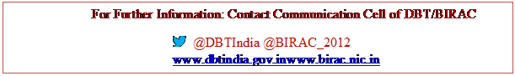

Source
Press Information Bureau, 01 March, 2021

