Taking science to the common man through various means including films, television programmes and other modes of communication
IISF-2020
Film star, Amitabh Bachchan, today, appreciated the efforts being made by the Union Ministry of Science and Technology to help take science to the common man through various means including films, television programmes and other modes of communication.
In a video address to the concluding session of India International Science Film Festival organised as part of the sixth India International Science Festival, he noted that science and technology had an important role to play in the socio-economic development of a country and emphasised that there was a need to impart knowledge and disseminate information on science and technology to the general public. The holding of the science film festival was commendable, he added.
The festival was organised by Vigyan Prasar, an autonomous institution of the Union Science and Technology Ministry with a mandate to popularise science and promote science communication in the country through films, television programmes and other modes of communication.
President of the Film and Television Institute of India and internationally acclaimed filmmaker Shekhar Kapur, who was the chief guest, said there was a need for scientists and filmmakers to work together as scientific pursuit requires a sense of curiosity and adventure and good filmmakers could help develop this quality among the younger generation by producing inspiring films on science and scientists.
Environmentalist and film director and producer, Mike Pandey, called for more monetary and other assistance to build up the capacity to utilise the powerful medium of documentary and other films on science-related themes.
Director, Vigyan Prasar, Nakul Parashar, announced that a special standing committee of filmmakers and other stakeholders would soon be set up for regular deliberation and recommendations on how to tap the potential of films to popularise science.
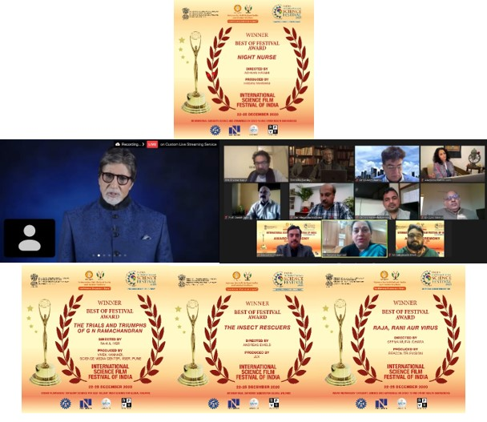

Source
Press Information Bureau, 25 December, 2020

