CSIR collaborates with Intel India and IIIT-Hyderabad to develop diagnostic solutions and risk stratification strategies to combat COVID-19

The ability to test faster and predict patients at riskis crucial to mitigating SARS-CoV-2 transmission. CSIR is working with Intel India and International Institute of Information Technology (IIIT), Hyderabad to help achieve faster and less expensive COVID-19 testing and coronavirus genome sequencing to understand epidemiology and AI-based risk stratification for patients with comorbidities.

As part of the initiative, Intel India is developing an end-to-end system that consists of multiple applications, testing devices, data collection/aggregation gateways, a data exchange SDK and an AI model-hub platform. CSIR constituent labs such as CSIR-IGIB, CSIR-CCMB, CSIR-IMTECH, CSIR-IIP, CSIR-CLRI and others will work with various hospitals and diagnostic chains in carrying out comprehensive diagnostics. IIIT-Hyderabad will develop risk stratification algorithms that can help in drug and vaccine discovery for long term preparedness to combat the epidemic.

Dr Shekhar C Mande, DG CSIR, observed, “Multi-disciplinary partnerships are key to tackling the challenge of COVID-19 and CSIR is happy to collaborate with IIIT-Hyderabad and Intel India which bring in complementary strengths in genomics, big data and AI.”

“Intel India is committed to working with CSIR and IIIT-Hyderabad to rapidly develop and deploy solutions in the fight against COVID-19. Intel creates technologies that enrich lives and this initiative exemplifies our focus on deploying advanced technology to find effective and scalable solutions for urgent local needs. Technology has become cheaper, more accessible and far more efficient since SARS-CoV-1 hit us and remains crucial in this fight against SARS-CoV-2 as it enables diagnostics, drug and vaccine discovery with higher predictability, speed and accuracy,” said Nivruti Rai, Country Head, Intel India and Vice President, Data Platforms Group, Intel Corporation.

PJ Narayanan, Director, IIIT-Hyderabad, noted, “It is exciting for IIIT-Hyderabad to work with the country’s top scientists from several CSIR laboratories and an industry leader like Intel on developing solutions for better sequencing of COVID-19 and other problems. We are looking forward to contributing our bit to this activity through our expertise in algorithms, science, and AI”.

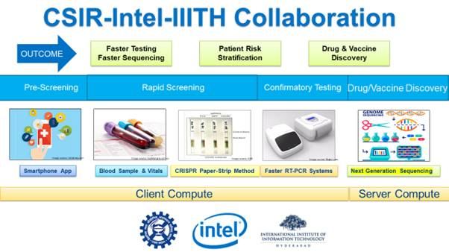

Source
Press Information Bureau, 15 May, 2020

