New wearable sensors capable of monitoring biomarkers from sweat can obviate necessity of invasive tests for monitoring health

Dr. Vinu Mohan A.M., scientist at CSIR-Central Electrochemical Research Institute (CECRI), Karaikudi, Tamil Nadu, a recipient of the INSPIRE Faculty Fellowship instituted by the Department of Science & Technology, Government of India, has introduced a flexible low cost, wearable sensor that can track sweat for monitoring the health and physiological status of the human body. It can obviate the necessity of blood and other invasive tests.

The wearable microfluidic sensor, which does not need a clean room, can be used for in situ monitoring of biomarkers such as lactate, Sodium (Na⁺⁾, Potassium (K⁺⁾, and Alkaline/acidic nature (pH) simultaneously from sweat samples. Using the INSPIRE Faculty fellowship, Dr. Vinu is improving upon the sensor to make it stretchable as well so that it can monitor the sweat during exercising and biking.

The sensor can analyse biomarkers from human sweat during exercise activities without transfer of signals. The high-throughput sweat sampling ability of the sensor facilitates continuous capture and transport of sweat over the surface of the device resulting in real-time analysis. The flexible sensor can be attached on the irregular skin surface and monitors the dynamic biomarker levels, and are important for clinical diagnosis and personalized point-of-care analysis.

Developing microfluidic sensors with rapid sweat sampling and multiplexed electrochemical recognition abilities are extremely important for accurate sweat biomarker analyses and continuous real-time monitoring of health.

In the sensor set up by Dr. Vinu’s research group, a fluidic channel captures real-time sweat and directs it through the active sensing electrodes for subsequent interference-free analyses. A miniaturized printed circuit board collects cross-talk-free sensor responses without the need for wires. The fully-integrated pump-less microfluidic device is mounted on the skin, and the regional variations in sweat composition are analyzed at the underarm and upperback locations during stationary biking. The epidermal patch can monitor the hydration level and oxygenation of muscles which is essential for fitness monitoring application. This research has been published in the journal ‘ACS Sensor’.

Dr. Vinu Mohan and his team are also exploring other reliable biofluids such as saliva and fluid in tissues as they contain abundant chemical markers that could reflect the underlying physiology of the human body. They are also in-parallel focusing on developing wearable energy storage devices as they are essential for powering wearable electrochemical sensors. An all-printed solid-state flexible and stretchable supercapacitor having serpentine-shaped, interdigitated, freestanding interconnects was recently developed and used as energy buffering element for powering a wearable pulse rate sensor. The work was published in NanoEnergy journal. Besides, his group is developing omni-directionally stretchable high-performance supercapacitors for self-powered wearable sensors.

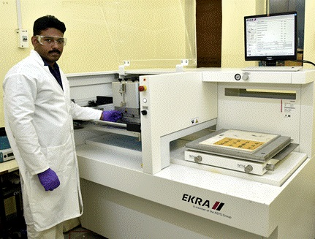
Dr. Vinu Mohan working in his lab

[Publications links:
https://dx.doi.org/10.1021/acssensors.0c02446
https://doi.org/10.1016/j.nanoen.2019.104055

For more details, please contact Dr. Vinu Mohan, Email: vinumohan756@gmail.com.]

Source
Press Information Bureau, 17 March, 2021

