Union Minister of Health & Family Welfare, Science & Technology and Earth Sciences Dr. Harsh Vardhan inaugurates state-of-the-art facilities at various research centres in Chandigarh and Mohali

Science has potential to resolve long standing issues: Dr Harsh Vardhan
Covid appropriate behaviour is important to beat the pandemic
Union Minister of Health & Family Welfare, Science & Technology and Earth Sciences Dr. Harsh Vardhan today inaugurated state-of-the-art facilities at various research centres in Chandigarh and Mohali.

Earlier in the day, the Minister inaugurated IMTECH Bio Innovation Centre, a Unit of the Atal Incubation Centre (AIC)-CCMB in CSIR-IMTECH (CSIR- Institute of Microbial Technology), Chandigarh. The Union Minister during an interaction with the media after inauguration said that the centre shall give a boost to the Government’s Atmanirbhar Bharat Mission as it shall become a hub for life-sciences and biotechnology startups and MSMEs from all over the country. He lauded the efforts of the scientific community and healthcare workers during the Covid-19 pandemic. Science has the potential to resolve long standing issues in any field of human endeavour, he added.

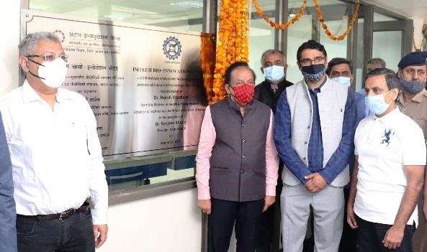
The Union Minister for Health & Family Welfare, Science & Technology and Earth Sciences, Dr. Harsh Vardhan inaugurating IMTECH Bio Innovation Centre, a unit of the Atal Incubation Centre (AIC) at CSIR- IMTECH in Chandigarh. The Director of CSIR-IMTECH, Dr. Rajiv Khosla is also seen.

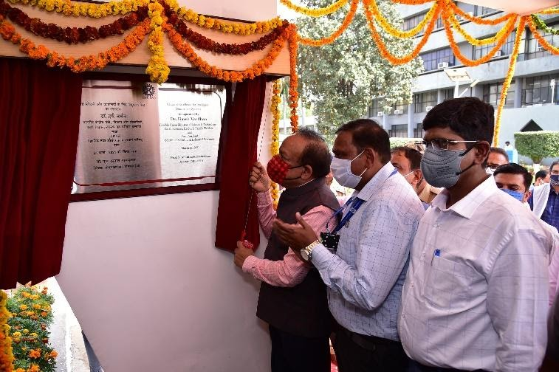

The Union Minister for Health & Family Welfare, Science & Technology and Earth Sciences, Dr. Harsh Vardhan inaugurating Centre of Excellence for Intelligent Sensors and System at CSIR-CSIO in Chandigarh.

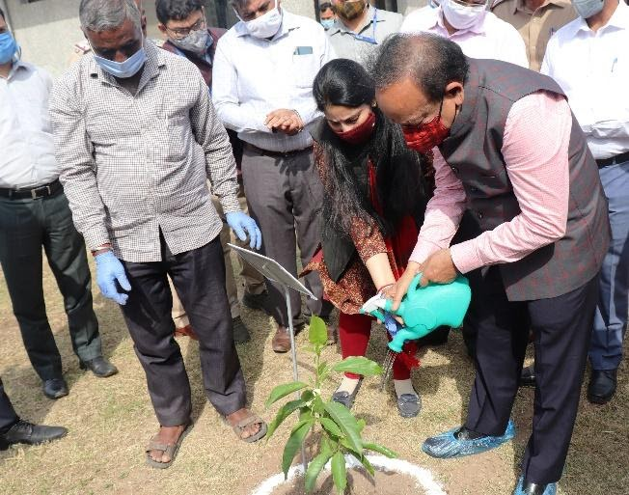

The Union Minister for Health & Family Welfare, Science & Technology and Earth Sciences, Dr. Harsh Vardhan planting a tree at CSIR-CSIO in Chandigarh.

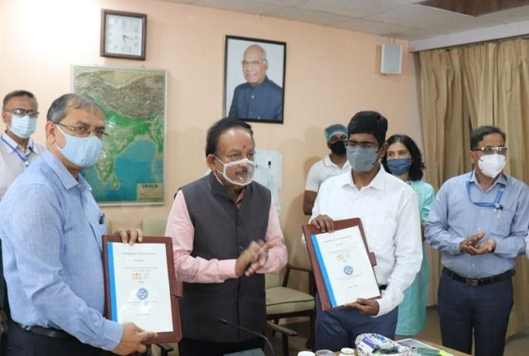

Signing of a Memorandum of Understanding (MoU) between CSIR-CSIO, Chandigarh and Punjab Engineering College, Chandigarh in presence of Union Minister for Health & Family Welfare, Science & Technology and Earth Sciences, Dr. Harsh Vardhan at CSIR-CSIO in Chandigarh.

The Union Minister also visited CSIR-CSIO (CSIR-Central Scientific Instrument Organisation), Chandigarh and inaugurated the Centre of Excellence for Intelligent Sensors and Systems. An MoU between CSIR-CSIO and Punjab Engineering College, Chandigarh was signed in his presence. He also interacted with young scientists who received National awards and fellowships in the past two years. Interacting with the media at CSIR-CSIO, he said Covid appropriate behaviour is important to beat the pandemic and everyone should strive to make it a Jan Andolan. He said that CSIO is committed to develop indigenous technologies as per the needs of the nation with minimum dependence on imports to provide impetus towards achieving the goal of Atmanirbhar Bharat.

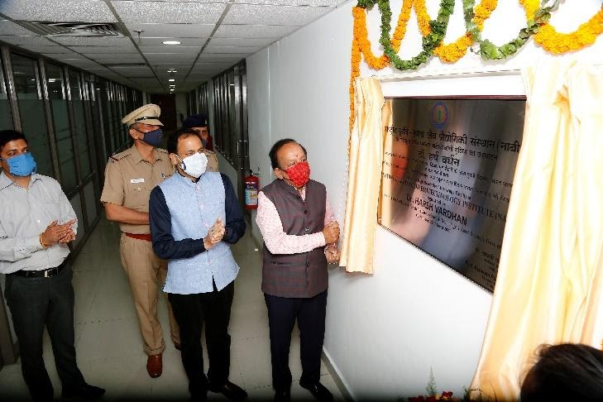
The Union Minister for Health & Family Welfare, Science & Technology and Earth Sciences, Dr. Harsh Vardhan inaugurating “Advanced High Resolution Microscopy Facility at National Agri-Food Biotechnology Institute (NABI) in Mohali, Punjab.

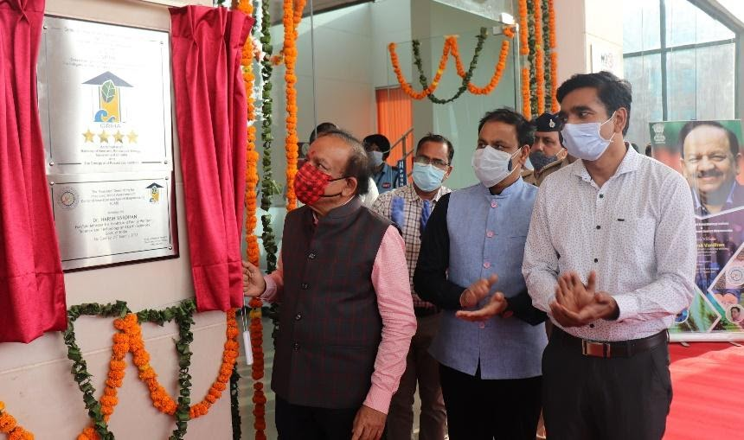

The Union Minister for Health & Family Welfare, Science & Technology and Earth Sciences, Dr. Harsh Vardhan unveiling the “Four Star” rating under GRIHA (Green Rating for Integrated Habitat Assessment) at Centre of Innovative and Applied Bioprocessing (CIAB) in Mohali, Punjab.

Later in the day, Union Minister Dr Harsh Vardhan inaugurated the “Advanced High Resolution Microscopy Facility” at the National Agri-food Biotechnology Institute (NABI) campus, Mohali, Punjab. He also unveiled a “Four Star” rating under GRIHA (Green Rating for Integrated Habitat Assessment) at Centre for Innovative and Applied Bioprocessing (CIAB) campus, Mohali, Punjab. In an interaction with Staff and students of NABI & CIAB, the minister said enthusiasm and zeal are important attributes of a scientist. He further said that research should not be confined to the laboratories and a new, proactive and innovative approach is needed to bring it to the masses.

CSIR-Institute of Microbial technology (IMTECH) started functioning in January 1984 with a mandate to undertake basic and applied research in emerging areas of microbial biotechnology, create capabilities in the services divisions, and to create technologies in the service of the nation.

Established in October 1959, Central Scientific Instruments Organisation (CSIO), a constituent unit of Council of Scientific & Industrial Research (CSIR), is a premier national laboratory dedicated to research, design and development of scientific and industrial instruments. It is a multi-disciplinary and multi-dimensional apex industrial research & development organisation in the country to stimulate growth of the Instrument Industry in India covering a wide range and applications.

NABI is the first Agri-Food Biotechnology Institute, established in India on 18th February 2010. NABI is a unique institute that has undertaken various overlapping research activities encompassing the areas of Agriculture, Food and Nutrition biology. Center of innovative and Applied Bioprocessing (CIAB), Mohali was established on 1st May, 2012. The Institute works for research and innovation about bio-resources and exploits the scope of utilizing the agriculture waste to create high quality products and secondary agricultural by-products.

Source
Press Information Bureau, 21 March, 2021

