DST’s journey of catalyzing innovation, entrepreneurship and incubation report launched

Besides nurturing of 3,681 startups under incubation through the network of 153 Incubators created by DST, generation of 1992 intellectual property has been reported

A report on the journey of the National Science and Technology Entrepreneurship Development Board (NSTEDB) in catalyzing innovation, entrepreneurship, and incubation was launched by the Secretary Department of Science and Technology, Professor Ashutosh Sharma at an online programme earlier this week.

“The Department of Science and Technology (DST) has played a significant role in fostering and nurturing the fledgling startup ecosystem by steering it through its strong network of Incubators through the National Science and Technology Entrepreneurship Development Board (NSTEDB). The last five years have been significant in bringing this to fruition, as is evident from the report,” Professor Sharma, Secretary DST, said while launching the report.

The concerted efforts of NSTEDB, DST during last 5 years for supporting innovation-driven entrepreneurship and fuelling incubation activity in institutions of higher learning has gained momentum and traction with speed and scale,” said Dr. Anita Gupta, Head NSTEDB.

Programs like National Initiative for Developing and Harnessing Innovation (NIDHI-) initiated by NSTEDB, aligning its activities with the National Initiative of Startup India and Standup India has played a significant role in energizing the incubator led innovation value chain. It played a crucial role in strengthening the academic-led innovation and startup ecosystem in the country in last 5 years. This activation process included a range of measures like establishments of a network of technology business incubators, scouting innovations, supporting ideas to prototypes, enabling transition from being innovators to startups, provision of timely seed funding to the incubated startups, and support to scale up the startups through focused mentorship, partnerships, and networks.

These efforts have been distributed across all geographical regions of the nation. Besides, the nurturing of 3,681 startups under incubation through the network of 153 Incubators created by DST, generation of 1992 intellectual property has been reported. Further, in last five years, the cumulative direct employment generation of 61,138 and Rs 27,262 crores of economic wealth creation are the key highlights of the Impact Report. The holistic efforts of DST have also ignited the spirit of innovation and entrepreneurship and added to the multiplier effect across the nation. It has also made good efforts to bring global recognition to a select group of awarded startups nurtured and supported through this ecosystem.

The report also indicates a fivefold increase in investments raised by the seed supported startups as a follow on funding from angels, venture capitals, and other stakeholders with significant valuation gains. Overall, NSTEDB approach has leveraged the technological strength of the higher learning institutes to the benefit of the startups through a network of academic incubators seeded and supported by it. It has led to an effective incubation support system that led to success of these fledgling startups.

The collective strength and power of NIDHI program, the DST Incubator network and its startups was tested successfully during the COVID 19 pandemic through the Centre for Augmenting WAR with COVID-19 Health Crisis (CAWACH) program by supporting various solutions to resolve the crisis.

The report was launched in the presence of the DST supported incubator community and the NSTEDB Team.

Link for Report

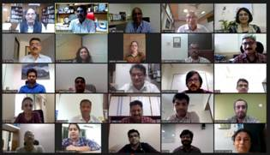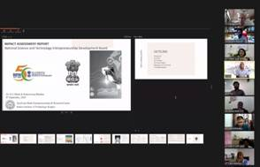

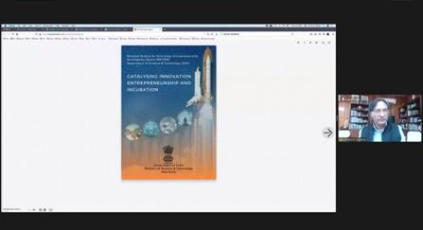

Source
Press Information Bureau, 10 September, 2020

