Science-based website on COVID 19 launched
It is a multi-institutional, multi-lingual science communication initiative, called `CovidGyan’
On-Campus Outreach and Awareness for COVID- 19
The facilities include a campus email helpdesk, a campus messaging service, a phone helpline, and a peer support line

With COVID-19 fear striking the nation at an exponential rate, scientists and engineers in the country are collaborating at an unparalleled scale to understand all the aspects of the pandemic.
The topics covered range from the exact behaviour of the novel coronavirus (SARS-CoV-2), transmission dynamics of the Corona flu and its diagnostics to innovative technologies to scale up the fight, means of coping up with physical distancing, and critical assessment of communications.
To bring the scientific and factual aspects of this pandemic outbreak on to public domain, a multi-institutional, multi-lingual science communication initiative, called `CovidGyan’ has been created.
The initiative is the brainchild of Tata Institute of Fundamental Research (TIFR), Indian Institute of Science (IISc), and Tata Memorial Centre (TMC). Several other prominent partners have since joined this noble effort including Vigyan Prasar, IndiaBioscience, and the Bangalore Life Science Cluster (BLiSc), which includes Institute for Stem Cell Science and Regenerative Medicine (InStem), Centre for Cellular And Molecular Platforms (C-CAMP), and National Centre for Biological Sciences (NCBS).
An outcome of this initiative is the launch of a website that went live on April 03, 2020. This website also named CovidGyan serves as a hub to bring together a collection of resources in response to the COVID-19 outbreak. These resources are generated by public supported research institutions in India and associated programs. The content presented here relies on the best available scientific understanding of the disease and its transmission.
Apart from being an authentic source of information, the primary objective of this website is to create public awareness and bring in a holistic approach to the understanding of this disease and potential means to mitigate it. Further, it would aid as a ‘go-to’ repository of information regarding COVID-19. It is designed with multi-faceted aspects to ‘right information’ through talks from eminent scientists in audio/podcast formats, infographics, posters, videos, FAQs and mythbusters, and even links to scientific papers.

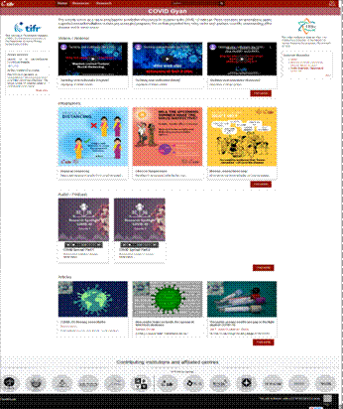\
A snapshot of the website
This informative website is not just user-friendly but also authentic, reliable and trustworthy. Since its launch, it has been widely shared by the scientific community through various social media platforms like Facebook and Twitter. Efforts are underway to provide the contents in multiple Indian languages to make it more versatile.
The id of the website is: https://covid-gyan.in

Meanwhile, in another novel initiative, Student volunteers of two major Bengaluru-based scientific institutions - Institute for Stem Cell Science and Regenerative Medicine (InStem) andNational Centre for Biological Sciences (NCBS) have set up several internal communication channels and help groups for their campus community to address fears and anxieties over COVID 19 pandemic.

Thefacilities include a campus email helpdesk, a campus messaging service, a phone helpline, and a peer support line, which is likely to stay for the campus in the years to come. The group of young researchers has also set up various volunteer groups to address student needs during the lockdown, as well as an ongoing effort to match specific research/programming/design skills with various short term and long term scientific challenges.
.
(Contact persons –Communications office, Bangalore Life Science Cluster
Amrita Tripathy: tripathya@instem.res.in
Mahinn Ali Khan: mahinnak@ccamp.res.in)

Source
Press Information Bureau, 13 April 2020

