Amid lockdown, SCTIMST gears up to meet COVID 19 pandemic with R&D, technologies and products

Sree Chitra Tirunal Institute for Medical Sciences and Technology (SCTIMST) is an Institution of National Importance under the Department of Science and Technology, Govt. of India stood out with its research, technologies, and innovations to meet the need of the hour in India’s fight against COVID 19.

Even though the Institute had to quarantine a number of staff when a foreign-returned doctor was detected with COVID 19 much before the nationwide lockdown, SCTIMST rose up to the occasion to bring out several technologies and products that could be crucial to combat the diseases. It's one step confirmatory diagnostic kit for COVID 19 developed in three weeks could solve India’s urgent need for rapid testing. The other R&D work on the issue included a UV Based Facemask Disposal Bin which can be used by health workers in hospitals and in public places for decontamination of used facemask, overhead covers and face shields, a superabsorbent material for liquid respiratory and other body fluid solidification and disinfection for the safe management of infected respiratory secretions and a disinfected barrier-examination booth for examining COVID-19 patients.

The confirmatory diagnostic test which can detect COVD 19 in 10 minutes and sample to result in time (from RNA extraction in swab to RT-LAMP detection time) is less than 2 hours will be one of the world’s first few. A total of 30 samples can be tested in a single batch in a single machine, thus allowing rapid testing of samples at a low cost.

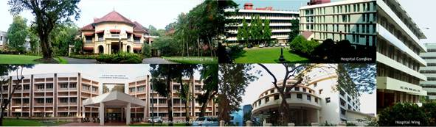

The Chitra UV Based Facemask Disposal Bin can decontaminate used materials like facemask and help break the infection chain, specially in hospitals. The know-how has been transferred to HMT Machine Tools, Ernakulam, Kerala. The superabsorbent material ‘Chitra Acrylosorb Secretion Solidification System’ reduces the risk for the hospital staff, the need for personnel for disinfecting and cleaning the bottles and canisters for reusing them and makes the disposal safer and easier. The disinfected examination booth is a closed one like a telephone booth for examining the patient without direct contact with the doctor to prevent any transmission of infection.
To speed up its contribution to the country’s COVID 19 response, SCTIMST has invited expression of interest from manufacturers/startups/social groups who are interested to co-develop and manufacture medical devices on a fast track mode for the development of AMBU bag based Ventilator, Ventilator Sharing Kit, Battery Operated Assistive Breathing Unit, Isolation Pods, Disposable Safety Face Shield and Deployable Field Units to support the distressing situation the epidemic COVID 19 has created. SCTIMST has tied up with Wipro 3D, Bengaluru, to jointly build up on a prototype of an emergency ventilator system based on the Artificial Manual Breathing Unit (AMBU), developed by SCTIMST followed by its clinical trial and manufacture.
The Institute is armed with three Wings: a tertiary referral super specialty hospital complex, a biomedical technology wing and an academic center for public health research (the Achutha Menon Centre for Health Science Studies), and a Technical Research Centre for Biomedical Devices. It focuses on high quality, advanced treatment of cardiac and neurological disorders, indigenous development of technologies for biomedical devices and materials, and public health training and research. SCTIMST has the status of a university and offers excellent research and training facilities, which has on its rolls some of the best teams of professionals in the field. It has proved its mettle with the efficiency with which it has responded to the crisis situation despite the constraints that the country is facing.

[For more details, please contact: Ms. Swapna Vamadevan, PRO, SCTIMST, Mob: 9656815943, Email: pro@sctimst.ac.in]

Source
Press Information Bureau, 29 April 2020

